ACA Module 9: Creating a Highly Available Environment

Student name: Duy Hung D Student ID: 104182779

Tutorial session: Monday 1:00PM

1. INTRODUCTION

Designing a highly available environment in AWS involves implementing a robust infrastructure that minimizes downtime and ensures uninterrupted access to applications. By distributing resources across multiple Availability Zones (AZs) within a region, utilizing services like Elastic Load Balancers for traffic distribution, and implementing Auto Scaling to dynamically adjust resources based on demand, you can enhance fault tolerance and scalability. Employing database replication, regular backups, and leveraging AWS services like CloudFront for content delivery further contribute to a resilient architecture. Integration with services like Amazon Route 53 for DNS management and AWS Global Accelerator for global traffic routing enhances overall reliability. Monitoring with Amazon CloudWatch, maintaining security best practices, and having a well-defined disaster recovery plan are integral components of building a highly available environment in AWS.

1. Main

**Task 1: Inspecting your VPC**

Choose VPC from Services menu, and then in the top left select Lab VPC from the Select a VPC blank.

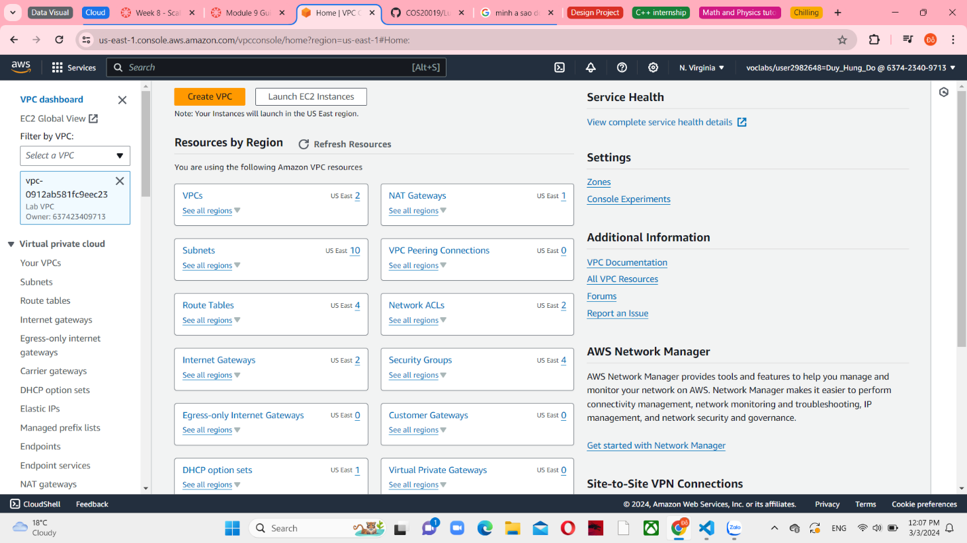

*Figure 1 VPC Instances and connect with Lab VPC*

Choose Your VPCs in the left navigation pane and you can see all information in the Details tab. The value of the IPv4 CIDR field is 10.0.0.0/16, indicating that this VPC encompasses all IP addresses starting with 10.0.x.x.

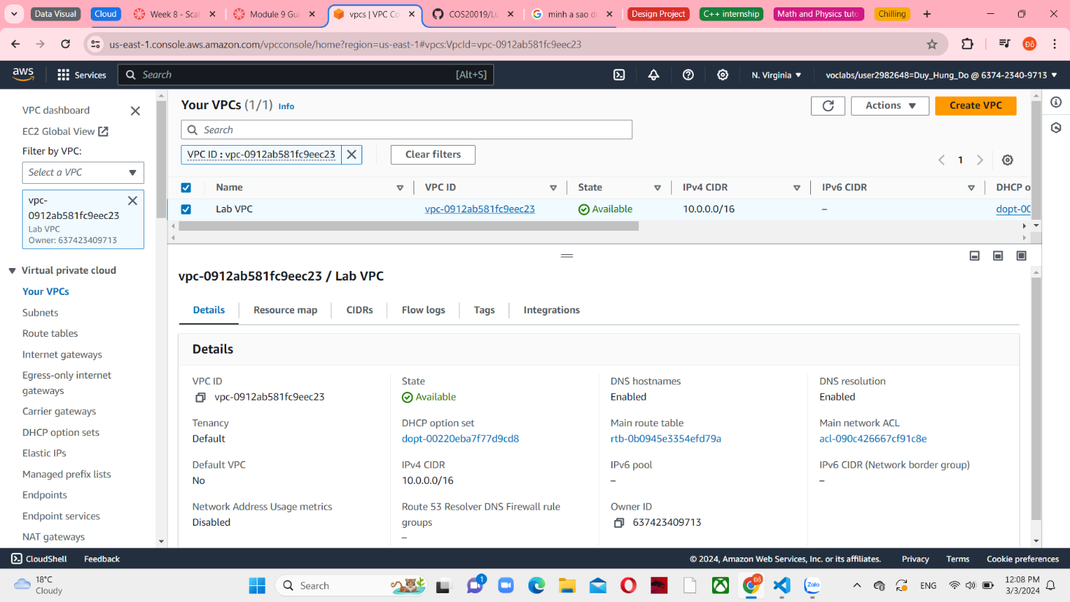

*Figure 2 Lab VPC and its IPv4 CIDR*

In the next step, choose Subnets and it have a default Public Subnet 1. It has connected with Lab VPC and have the IPv4 CIDR with the value 10.0.0.0/24.

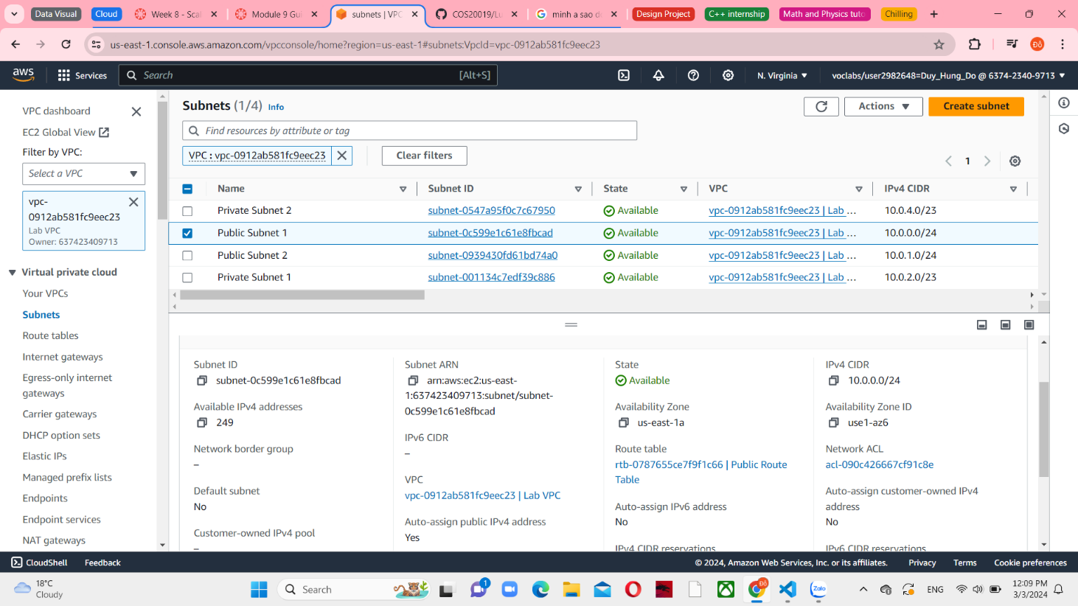

*Figure 3 Public Subnet 1 details*

To see more information, choose the Route table tab. The initial entry states that traffic intended for the Classless Inter-Domain Routing (CIDR) range for the VPC (10.0.0.0/16) will be directed within the VPC (local). The second record states that all traffic meant for the internet (0.0.0.0/0) is directed to the internet gateway (igw-) present in Lab VPC. This configuration designates the subnet as a public subnet.

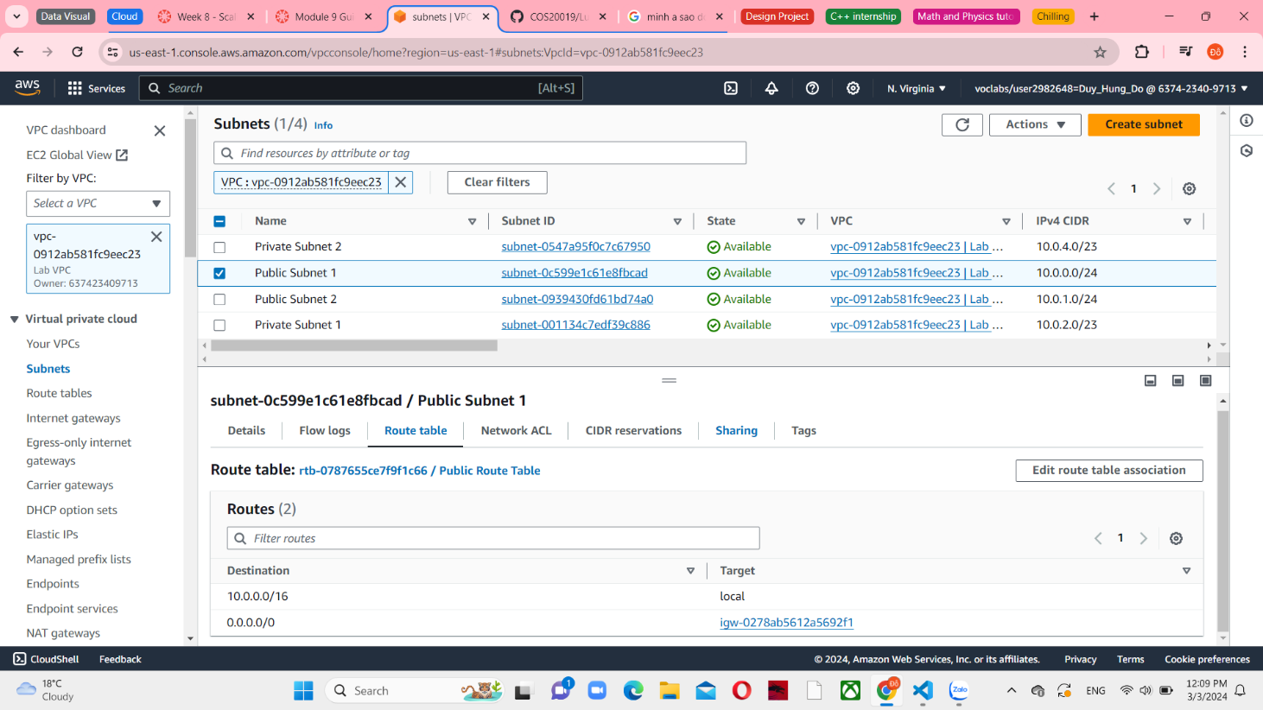

*Figure 4 Route table connect with Internet Gateway*

Choose the Network ACLs tab in this VPC. This tab provides details regarding the network access control list (network ACL) linked to the subnet. Currently, the rules are configured to the default settings. These rules allow unrestricted traffic to pass in and out of the subnet. However, if desired, the rules can be more limited by utilizing security groups.

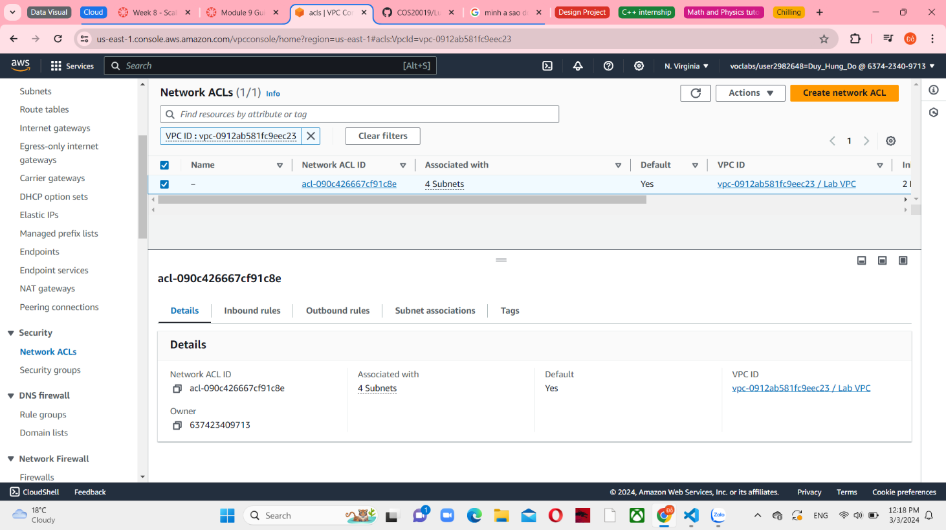

*Figure 5 Network ACLs with 4 subnets*

Choose internet gateways and you can see a LabIG has created. And it is already attached to Lab VPC.

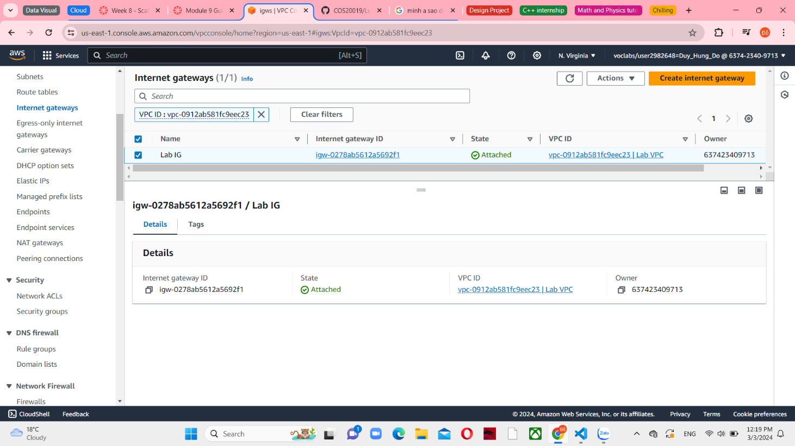

*Figure 6 Internet gateways details*

In the left navigation pane, choose Security Group and select Inventory-DB to see the Inbound rules tab. The security group includes a rule that allows MySQL or Aurora traffic (port 3306) from any location within the VPC (10.0.0.0/16). Later on, this configuration will be adjusted to only allow traffic from the application servers.

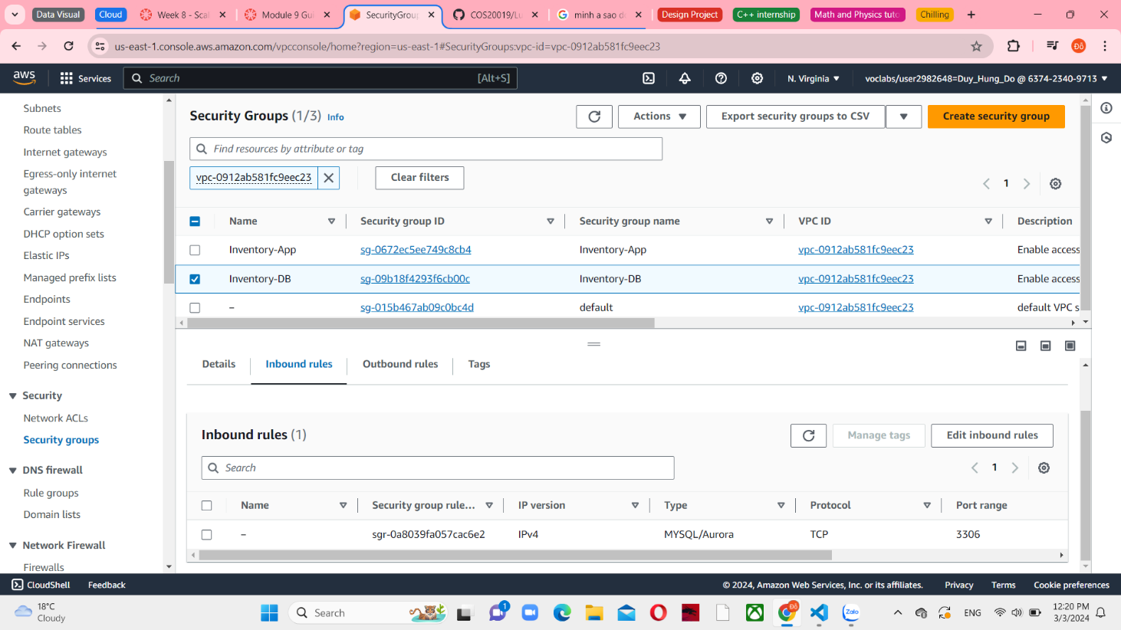

*Figure 7 Inventory-DB Inbound rules*

Choose the Outbound Rules tab. By default, all outbound traffic is permitted by security groups. Nevertheless, these configurations can be adjusted according to requirements.

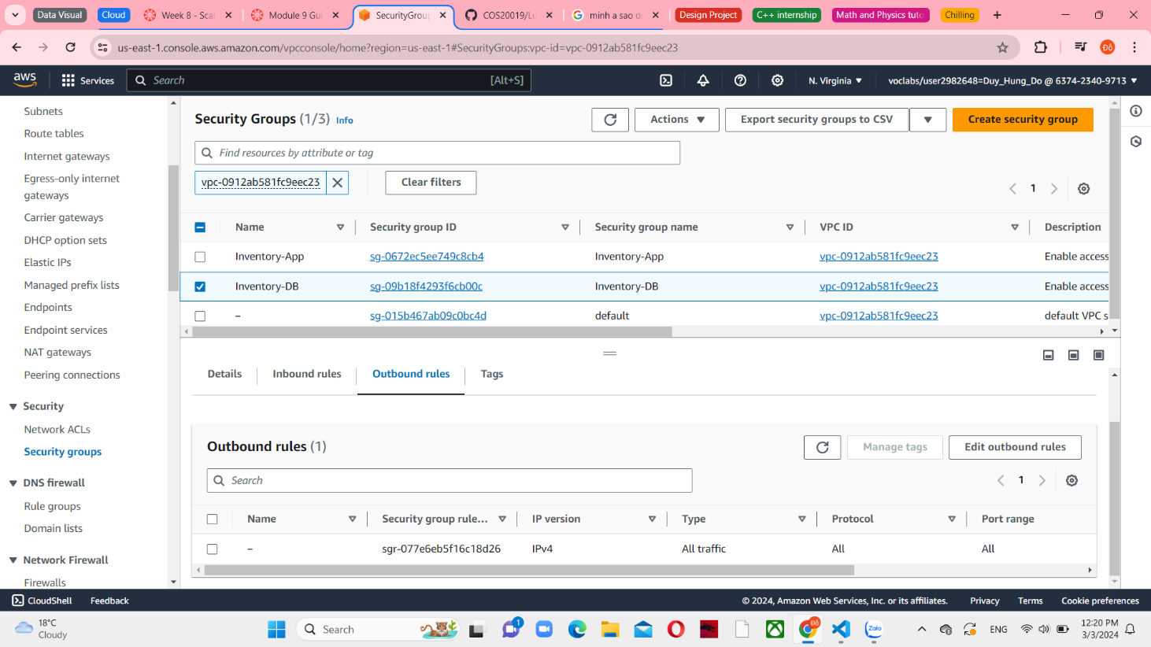

*Figure 8 Inventory-DB Outbound rules*

**Task 2: Creating an Application Load Balancer**

On the Services menu, choose Load Balancers m EC2 console

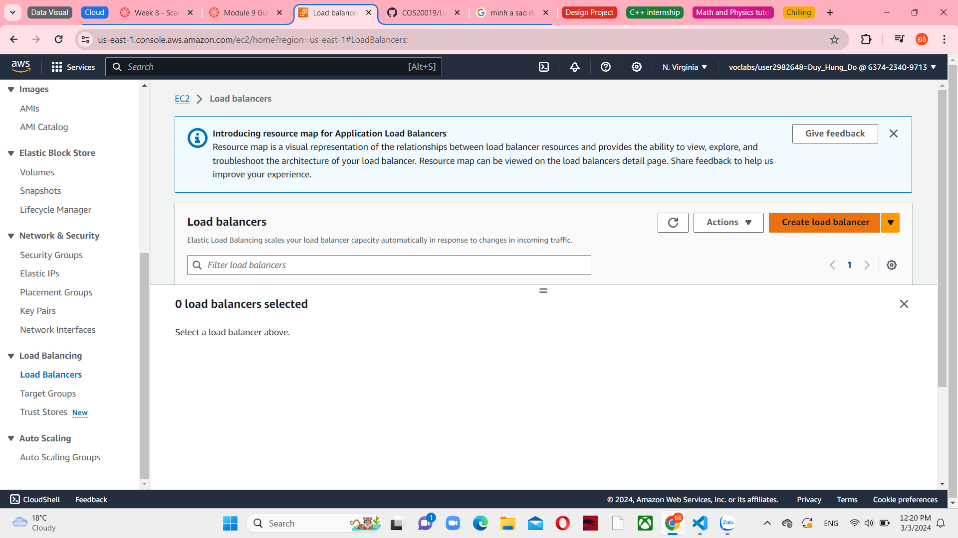

*Figure 9 Load Balancers menu*

Choose Create load balancer and Create an Application Load Balancer. It is in the first option.

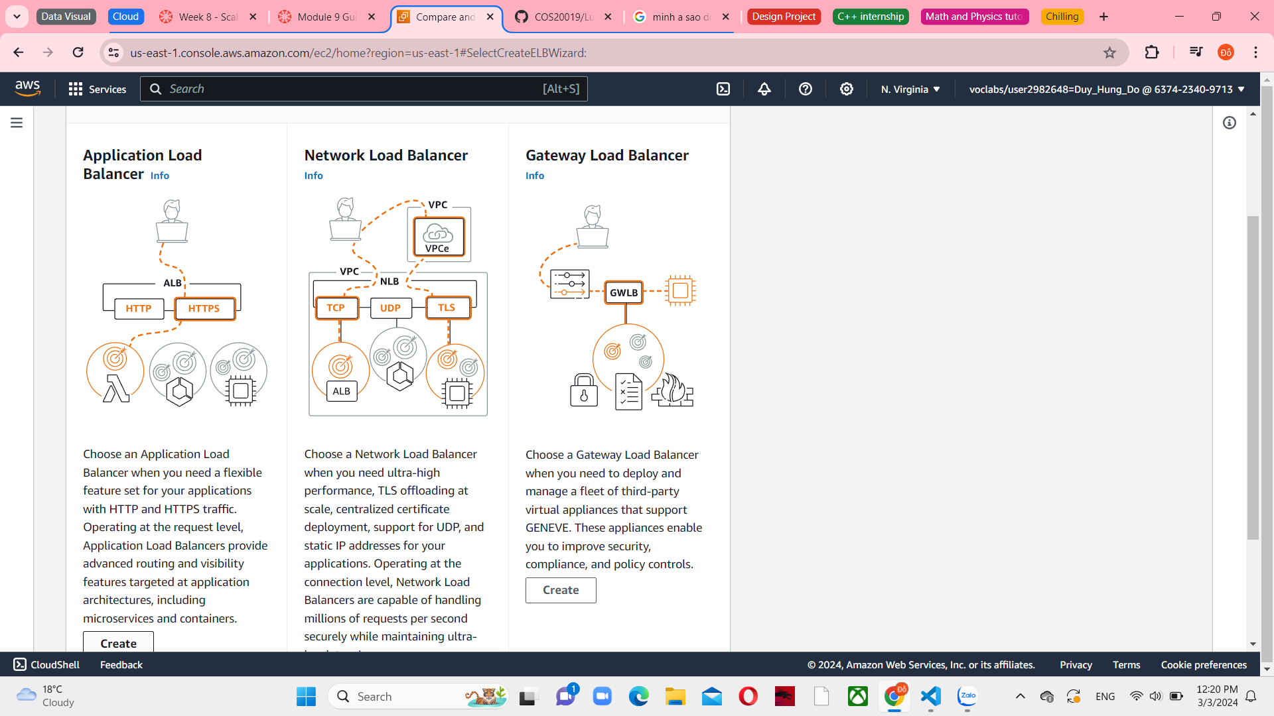

*Figure 10 Load balancer creation options*

Enter the value “Inventory-LB” as the Load blancer name.

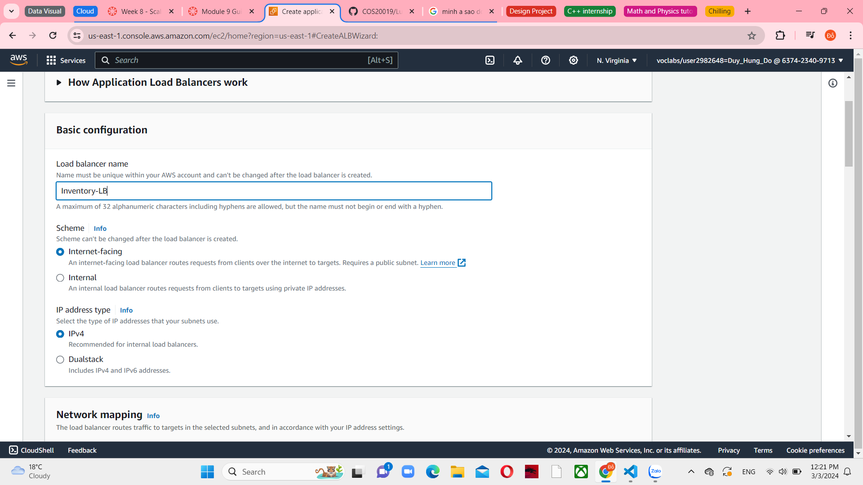

*Figure 11 Basic configuration in Load balancer*

In the Network mapping section, choose Lab VPC in VPC info. You will indicate the subnets that the load balancer should utilize. The load balancer will be public, thus you will choose both public subnets.

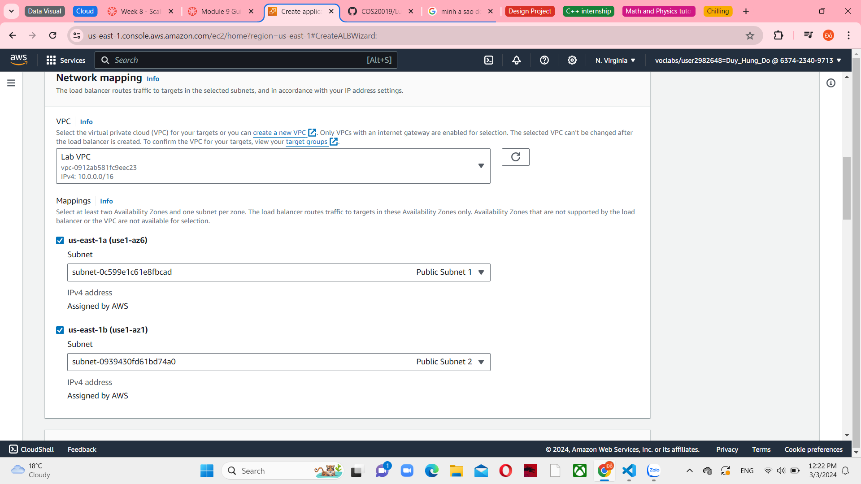

*Figure 12 Network mapping in Load balancing*

Select the Create a new security group hyperlink and it opens a new browser tab. And then, configure the group settings such as “Inventory-LB” is the security group name, “Enable web access to load balancer” is the description and connect with Lab VPC

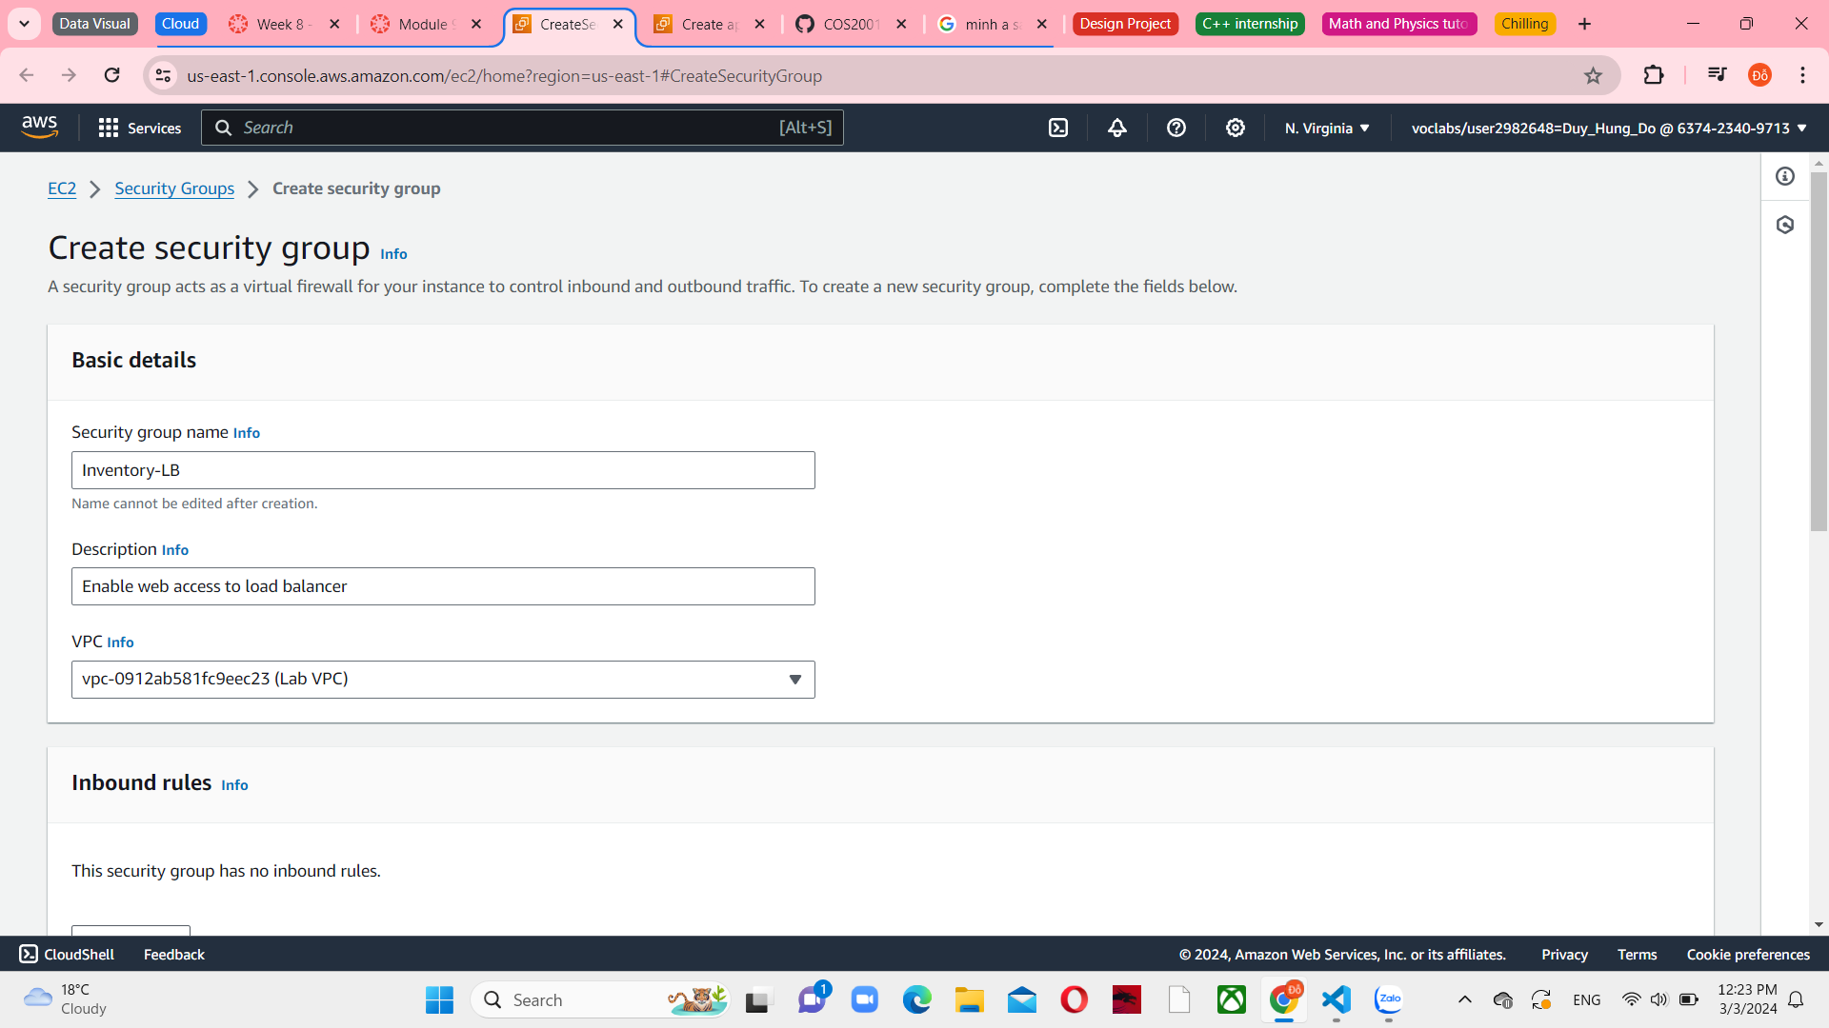

*Figure 13 Basic details group in security group*

In the inbound rules, choose Add rule and configure 2 types HTTP and HTTPS with the same Anywhere-IPv4 resources.

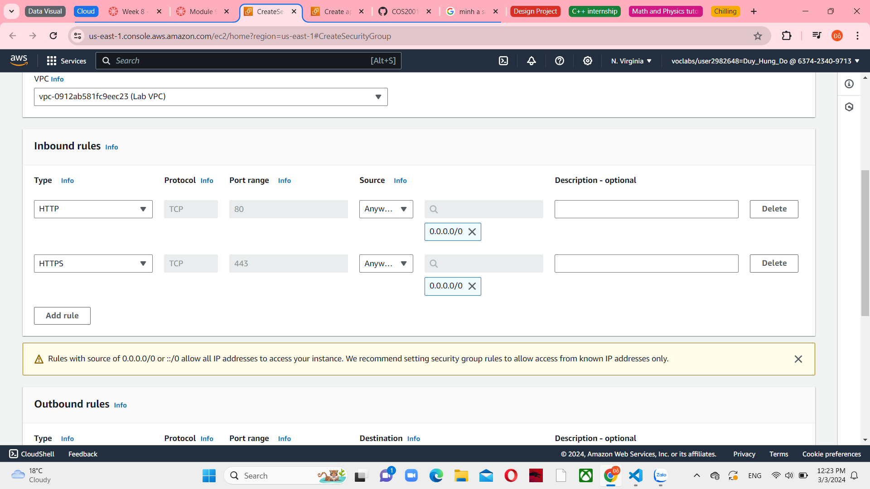

*Figure 14 Inbound rules in security group*

Choose Create security group and you can see a successful message.

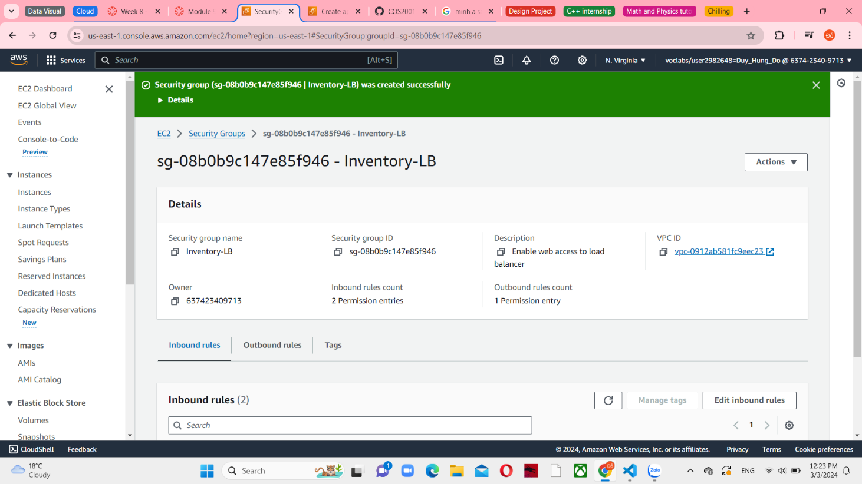

*Figure 15 Create Security group successfully*

And then assign the Inventory-LB security group against to Security groups in Load balancing. If you can’t see any group, you can choose the refresh icon. The notice that you have to drop the default security group.

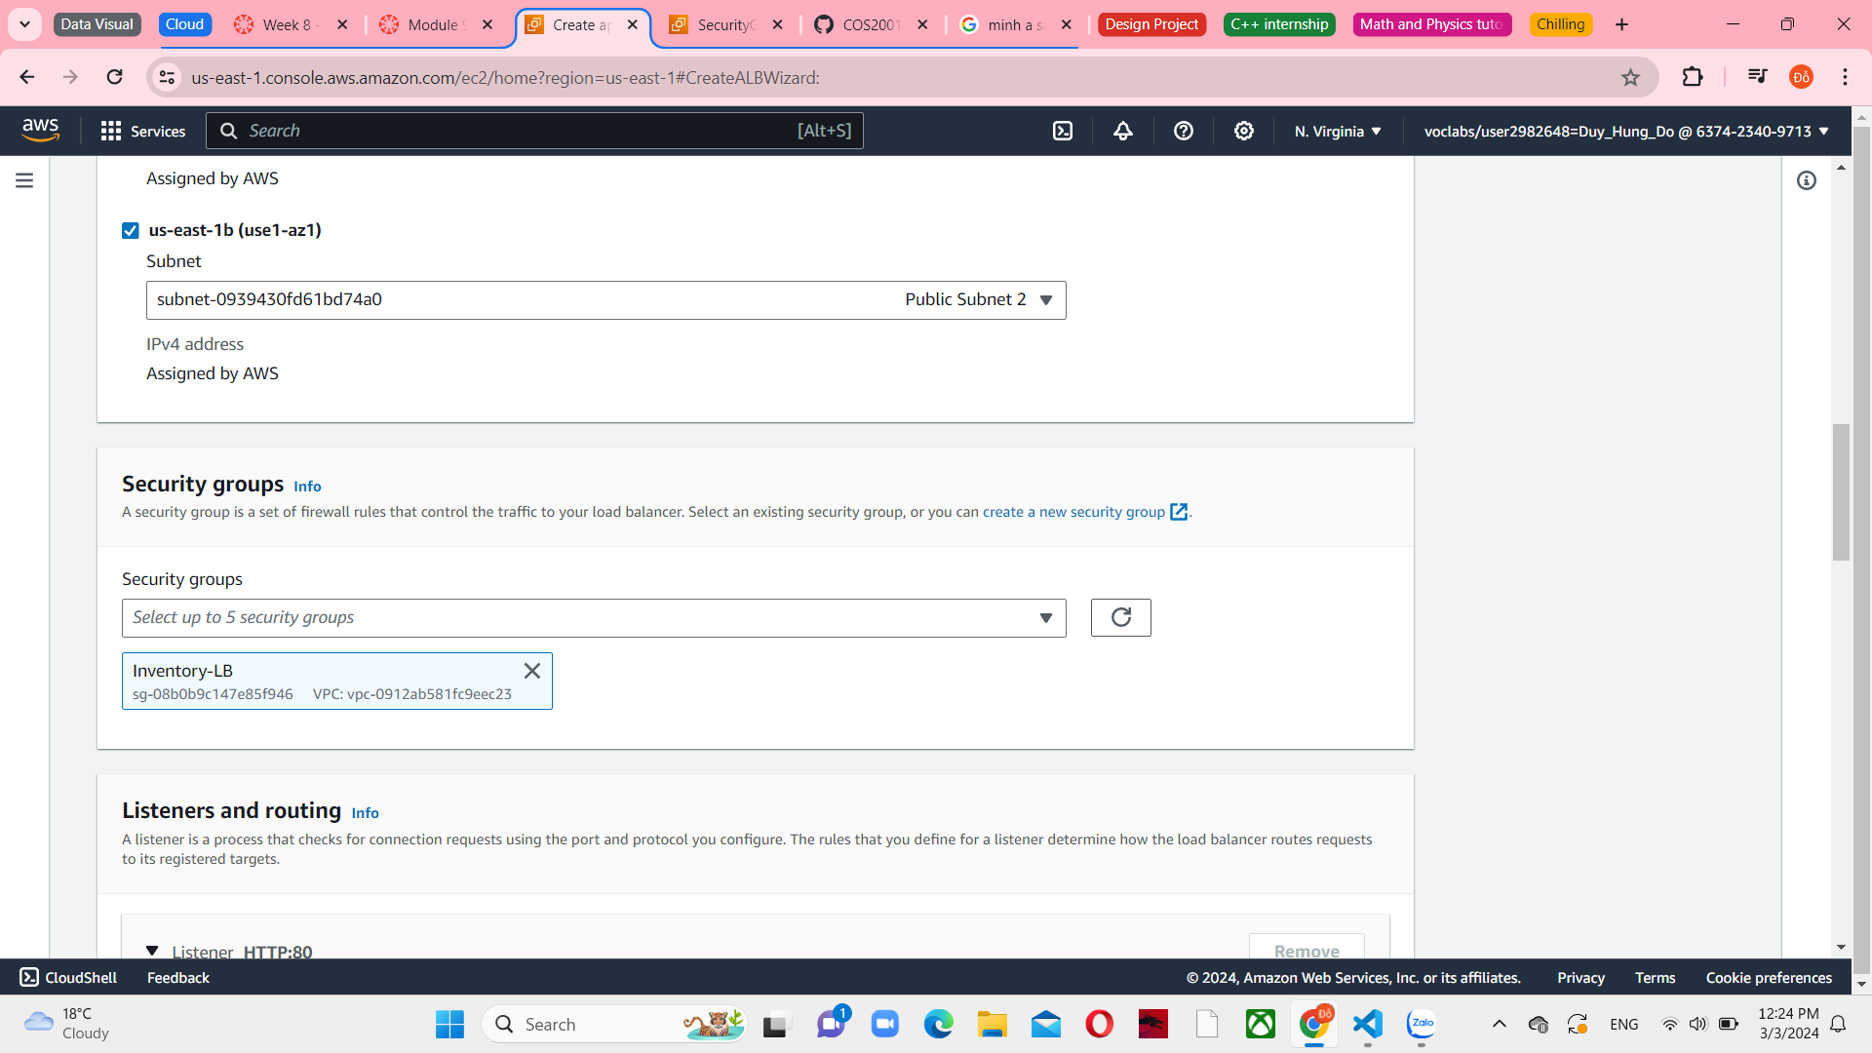

*Figure 16 Security group in Load balancing*

Create target group in Listeners and routing section. Target groups determine the destination for incoming traffic received by the load balancer. The Application Load Balancer has the capability to direct traffic to multiple target groups, depending on the URL of the incoming request. For instance, requests from mobile apps can be directed to a separate group of servers. It is worth noting that your web application will utilize a single target group.configure the Instances target type and the name is Inventory-App. And then choose Instances type and the Inventory-App named.

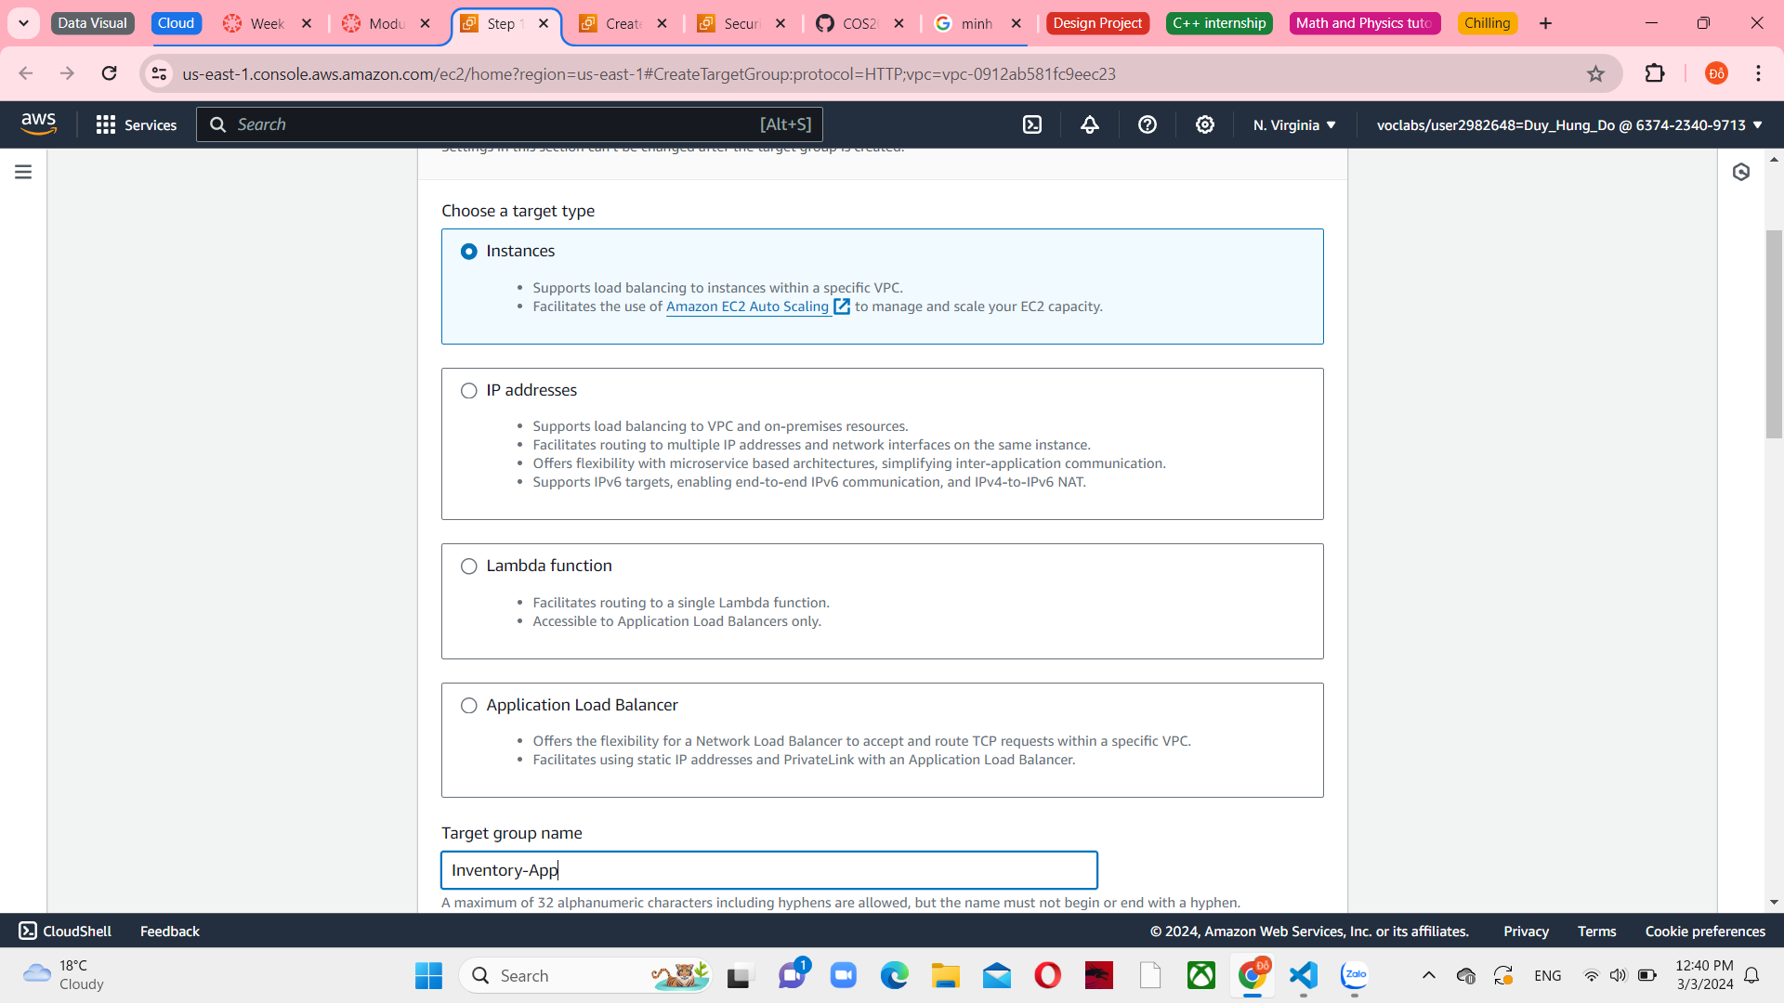

*Figure 17 Target group type and name*

Lab VPC is selected with IPv4 address type and HTTP1 protocol version

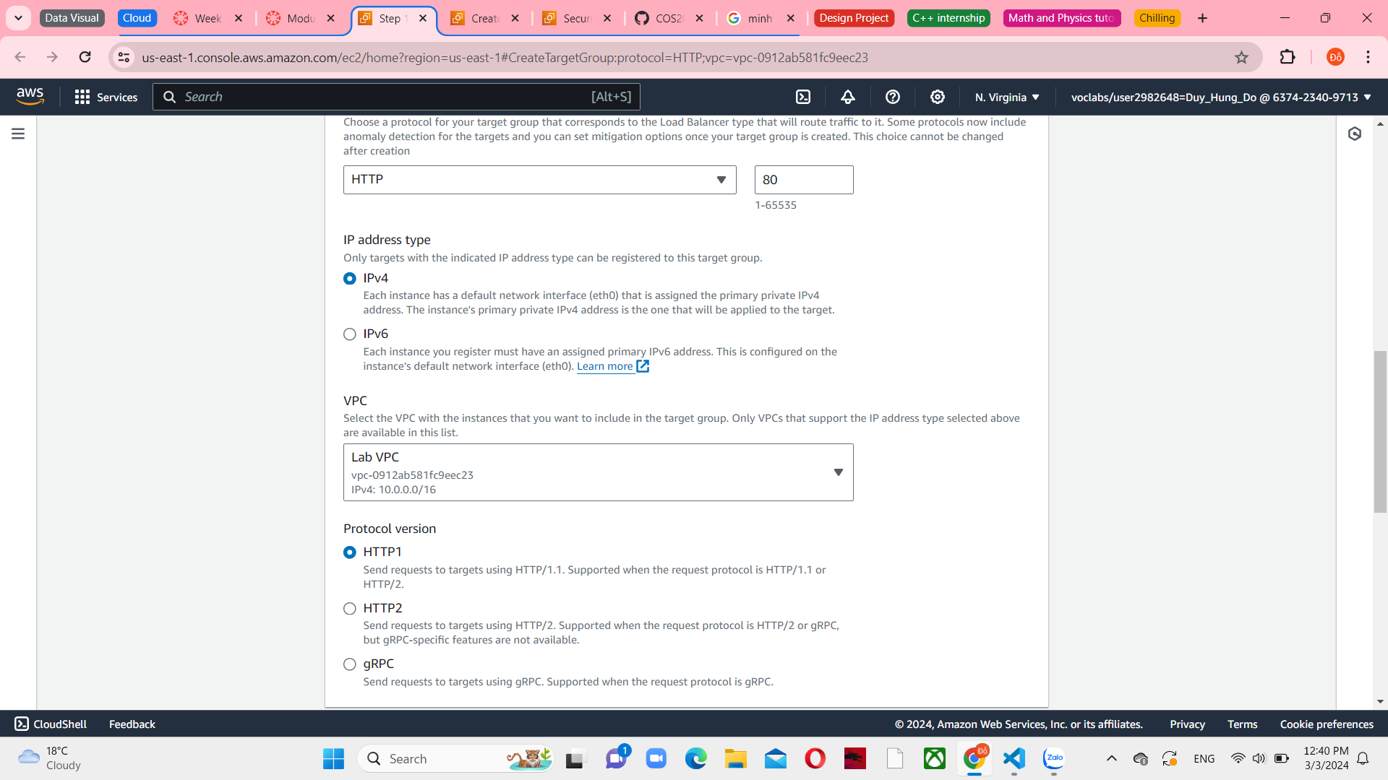

*Figure 18 Target group connect with Lab VPC*

Set the healthy threshold is 2 and interval in 10 seconds. The configurations you have selected will lead to the health check being executed every 10 seconds, and if the instance responds accurately two times consecutively, it will be deemed healthy.

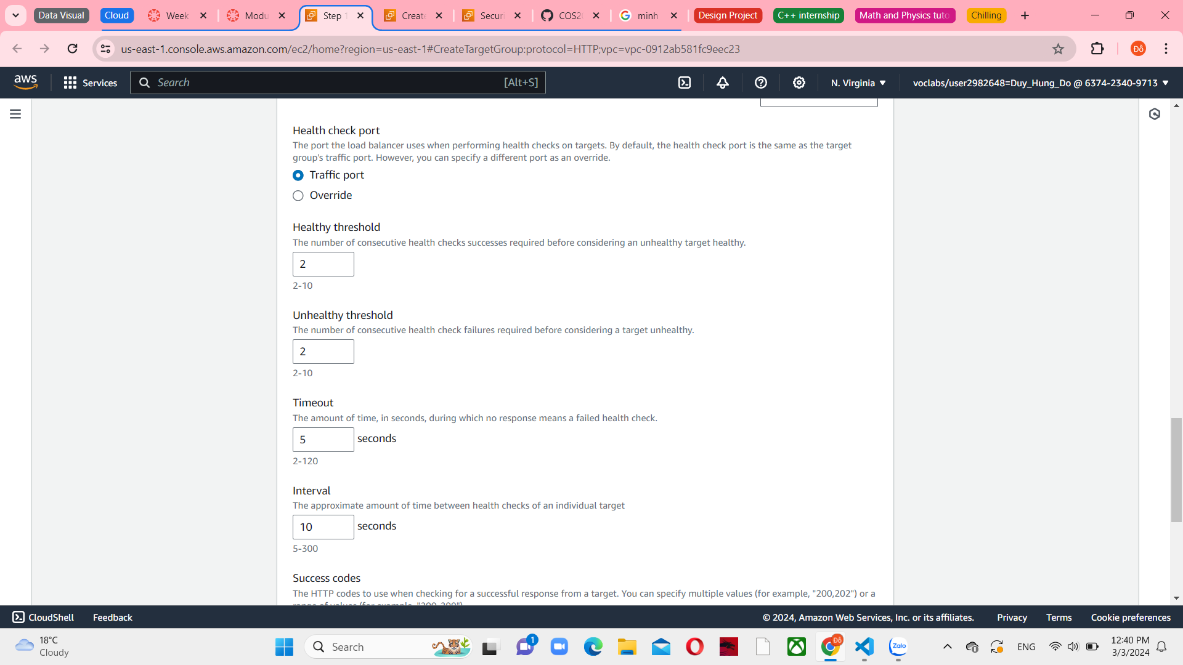

*Figure 19 Advanced health check settings*

Choose next and you can see the register targets screen appears. Review it and choose Create target group

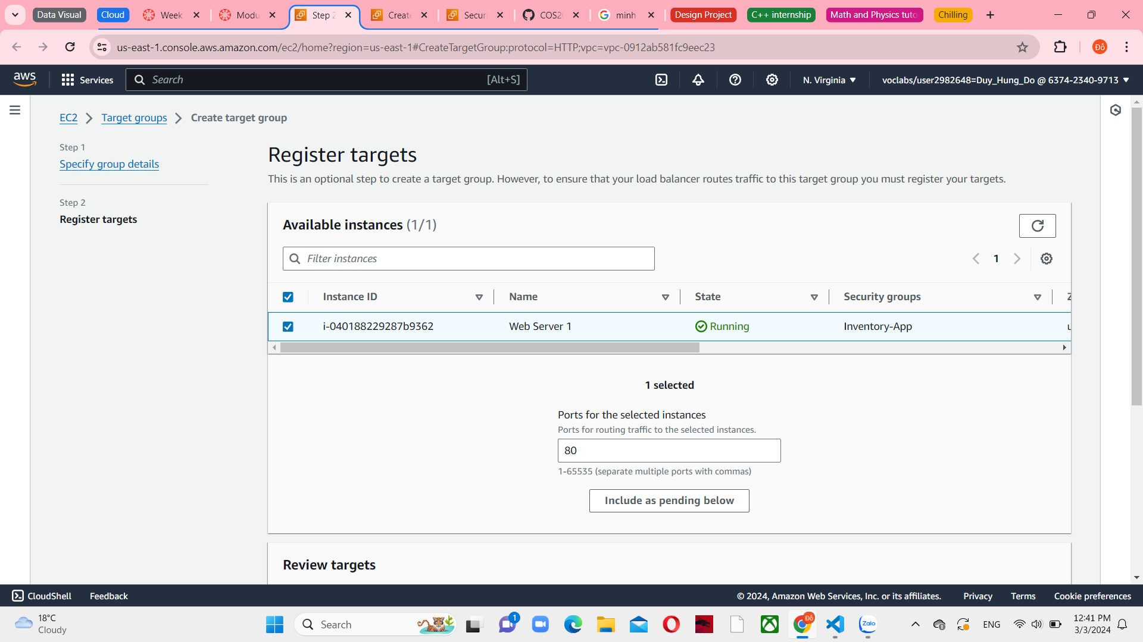

*Figure 20 Register targets menu*

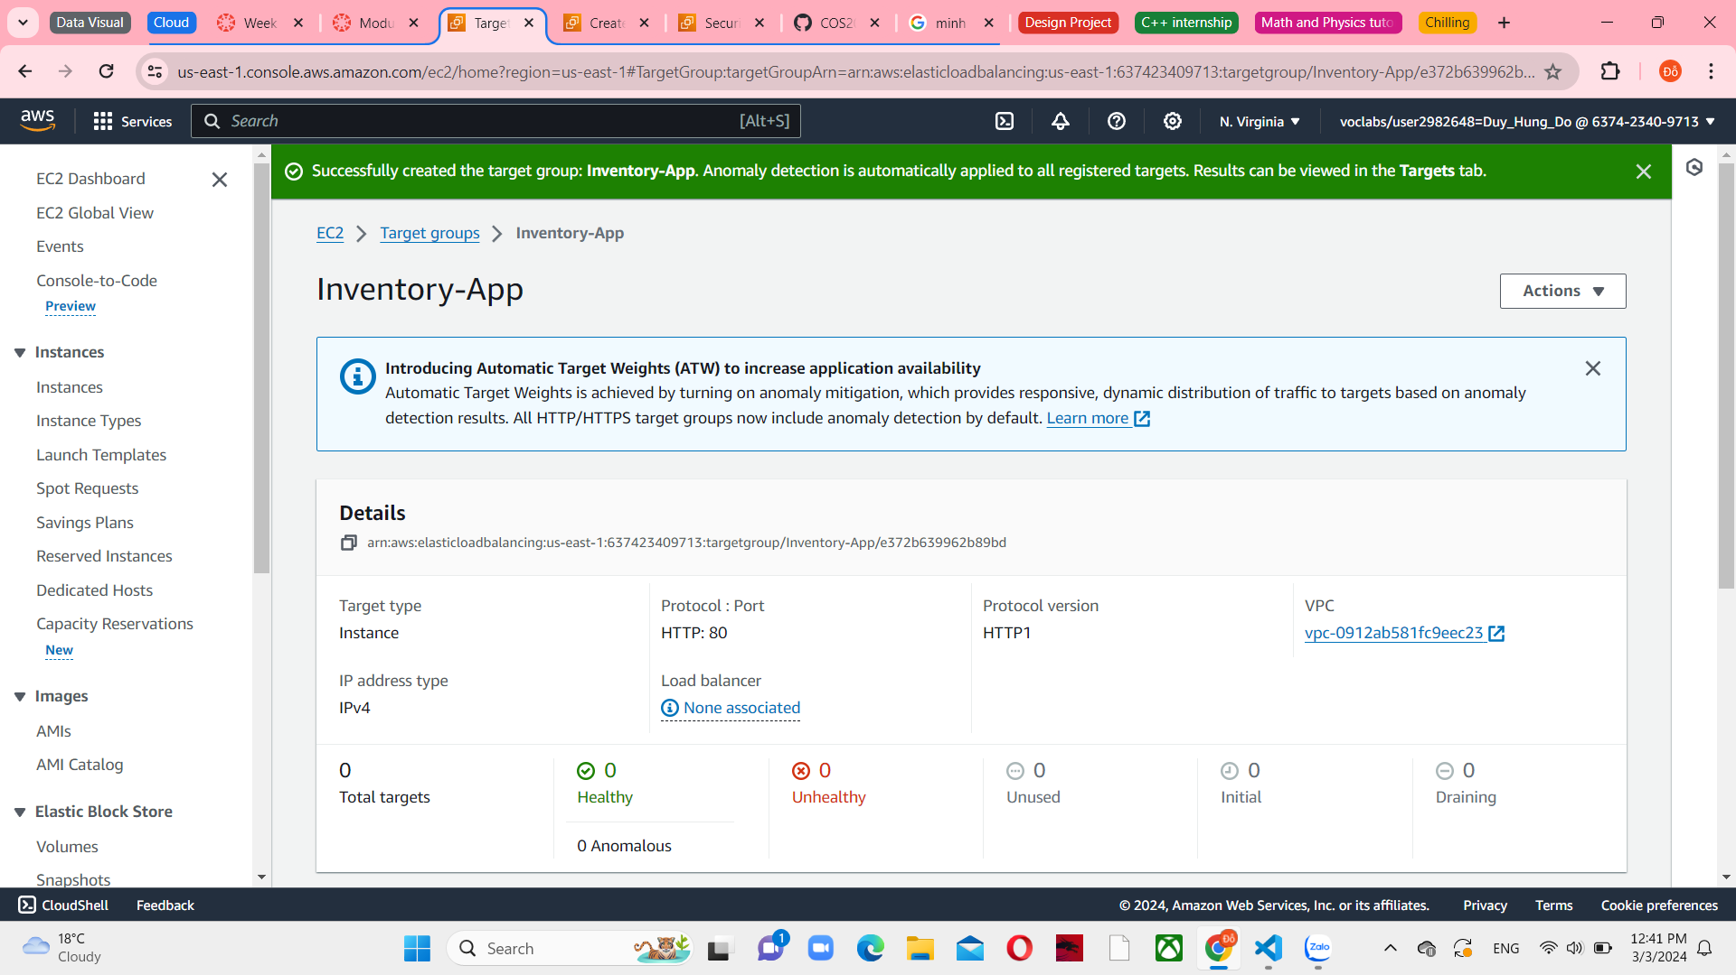

*Figure 21 Create targets group successfully*

For the Listener HTTP:80 set the Inventory-App target group just created in the Default action

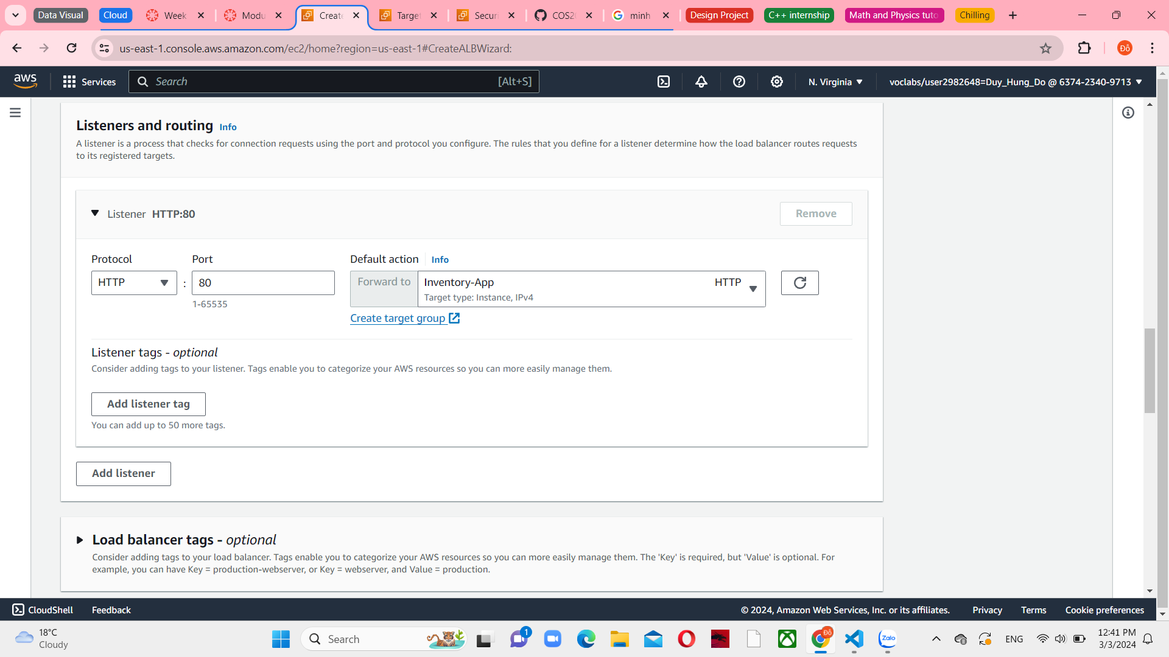

*Figure 22 Listeners and routing in Load balancer*

Choose Crate Load balancer and you can see a provisioning status of Inventory-LB. It means that the load balancer is successfully created.

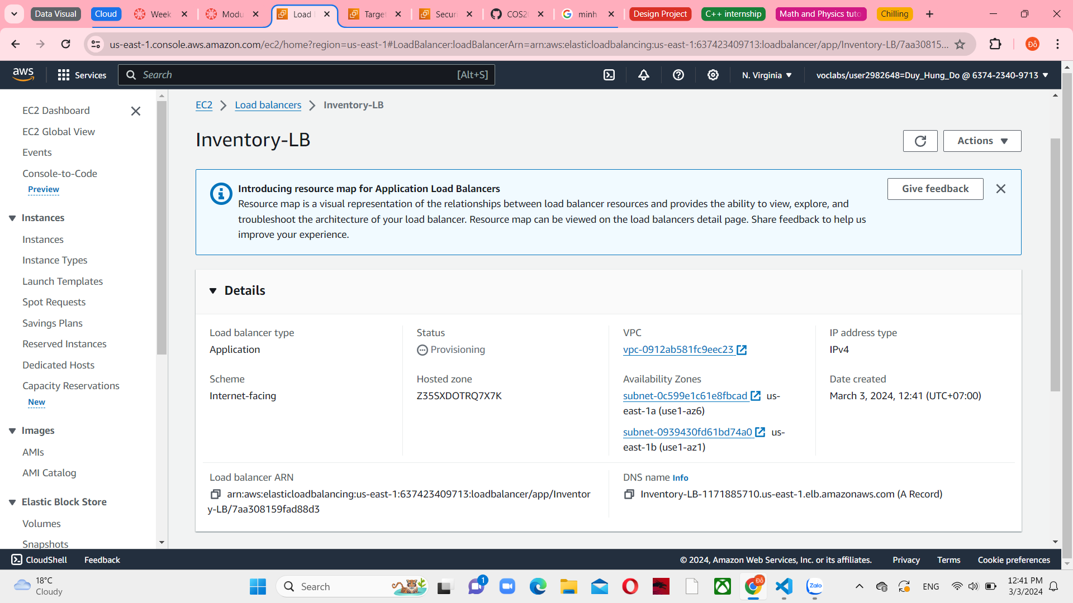

*Figure 23 Inventory-LB Load balancer details*

**Task 3: Creating an Auto Scaling group**

Choose EC2 from Services menu, and then choose Instances and see the status check for Web Server 1 displays 2/2 checks passed

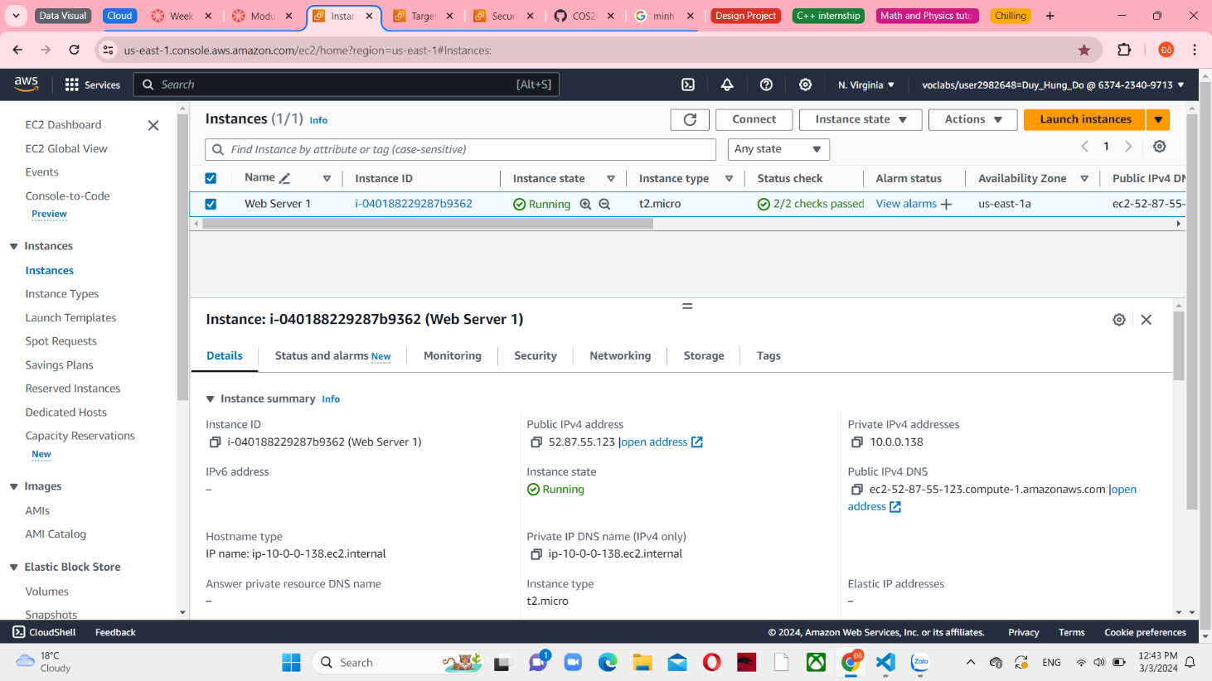

*Figure 24 EC2 Instances console*

After select Web Server 1, choose Image and templates in Action menu, and then Create image

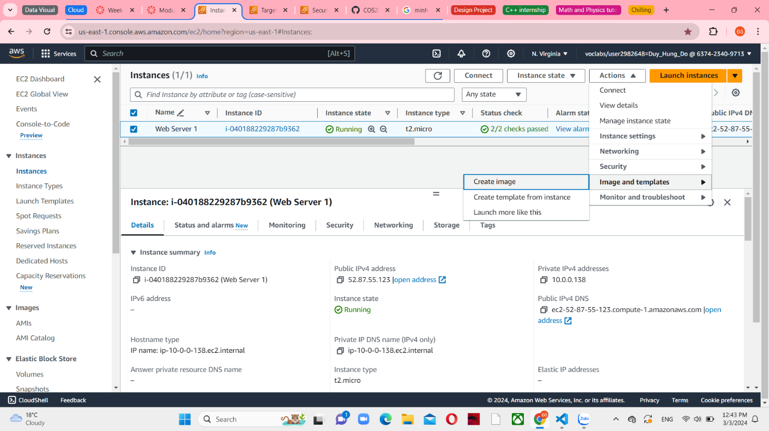

*Figure 25 Create image in Web Server 1 Instance*

Configure the Image name is Web Server AMI and the Image description is Lab AMI for Web Server

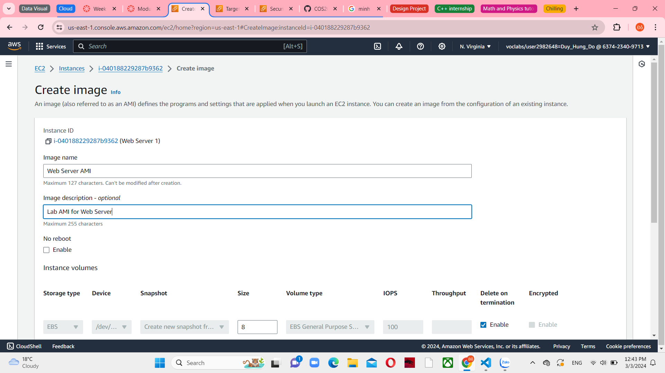

*Figure 26 Image information*

Choose Create image and then you can see a successful message in the top.

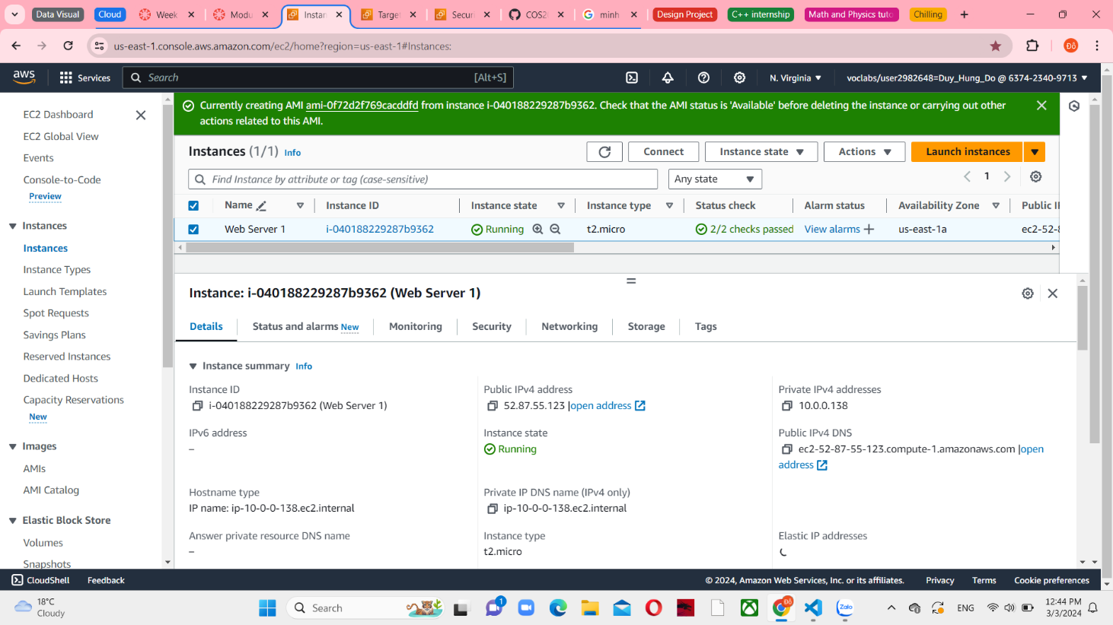

*Figure 27 Create image successfully*

In the left navigation pane, choose Launch Templates and create it. First, you will create a launch template, which is a template that an Auto Scaling group utilizes to launch EC2 instances. During the creation of a launch template, you provide details for the instances, including the AMI, instance type, key pair, and security group.

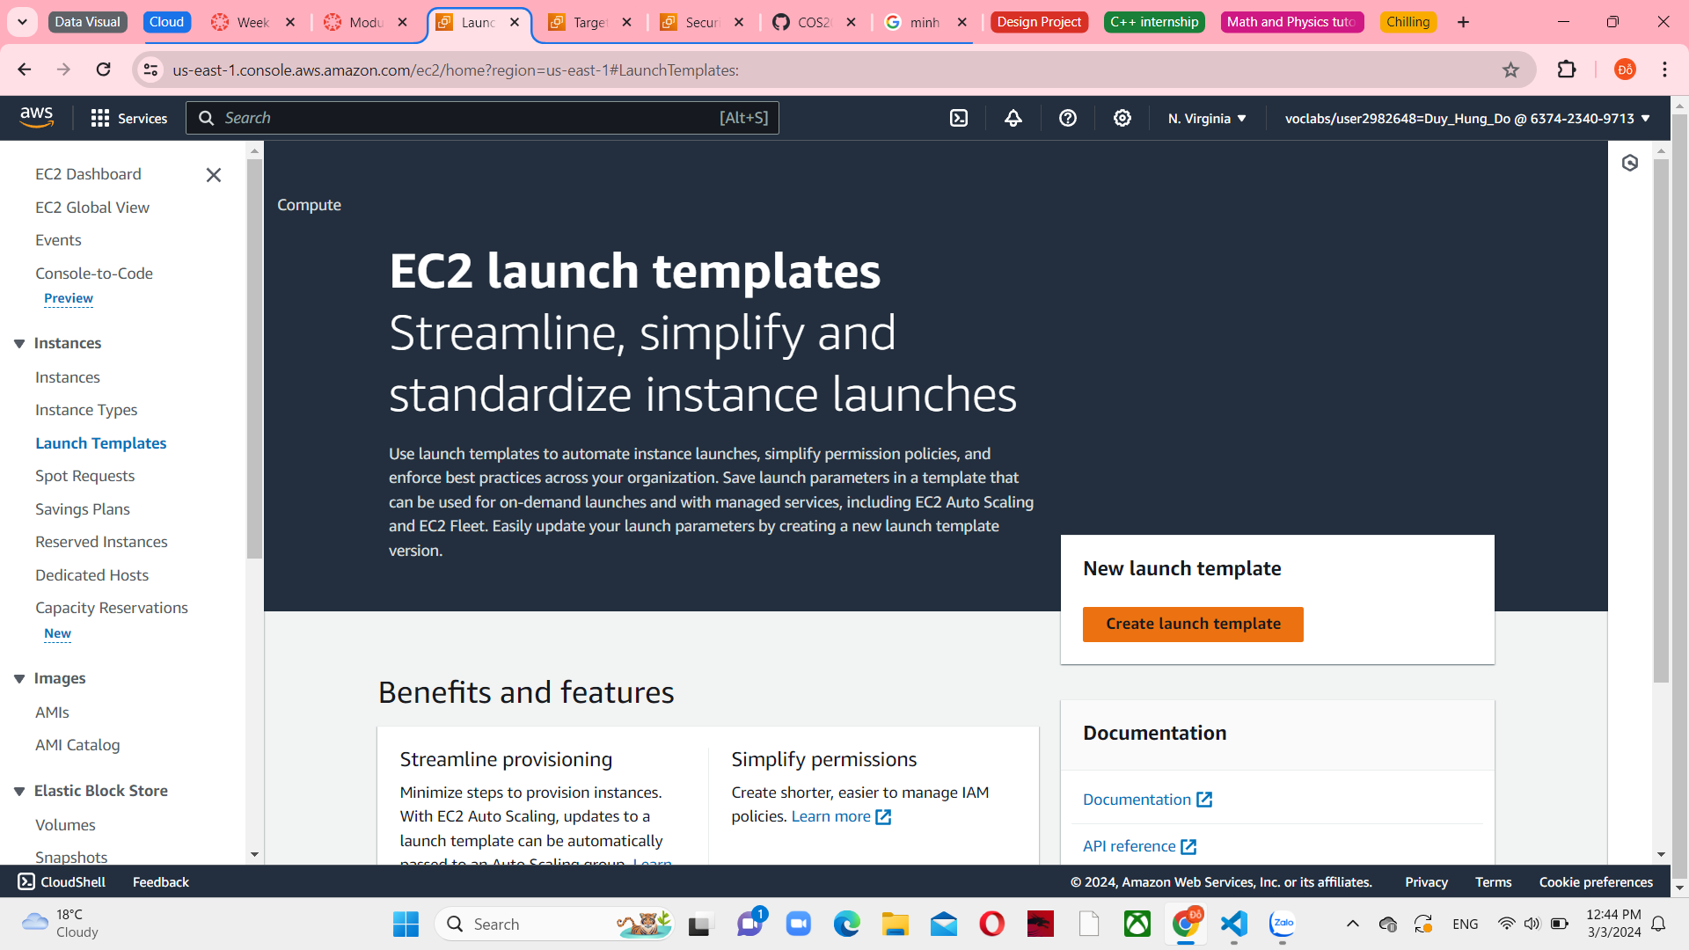

*Figure 28 Launch templates in EC2*

Set Inventory-LT as the Launch template name and select Provide guidance to help me set up a template that I can use with EC2 Auto Scaling under Auto Scaling guidance

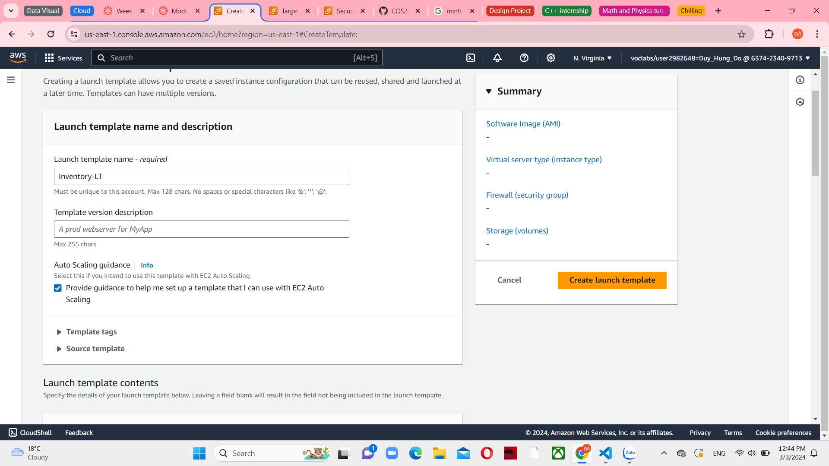

*Figure 29 Launch template name and description*

In the Application and OS images area, choose My AMIs, and then select Web Server AMI

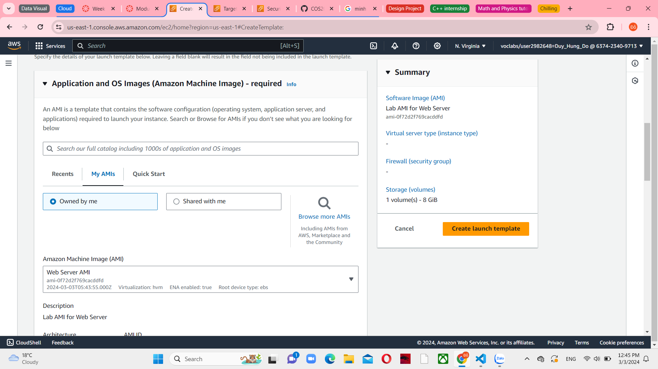

*Figure 30 Application and OS Images (Amazon Machine Image)*

Choose t2.micro as the Instance type and vockey as the Key pair name.

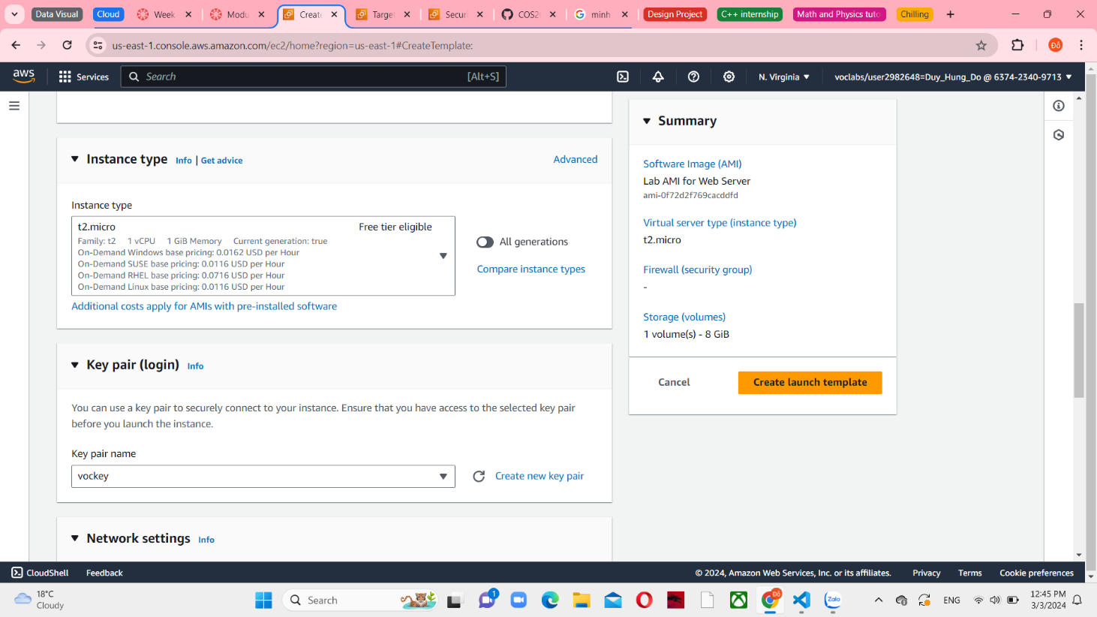

*Figure 31 Instance type and Key pair (login)*

Select Inventory-App as the Existing security group

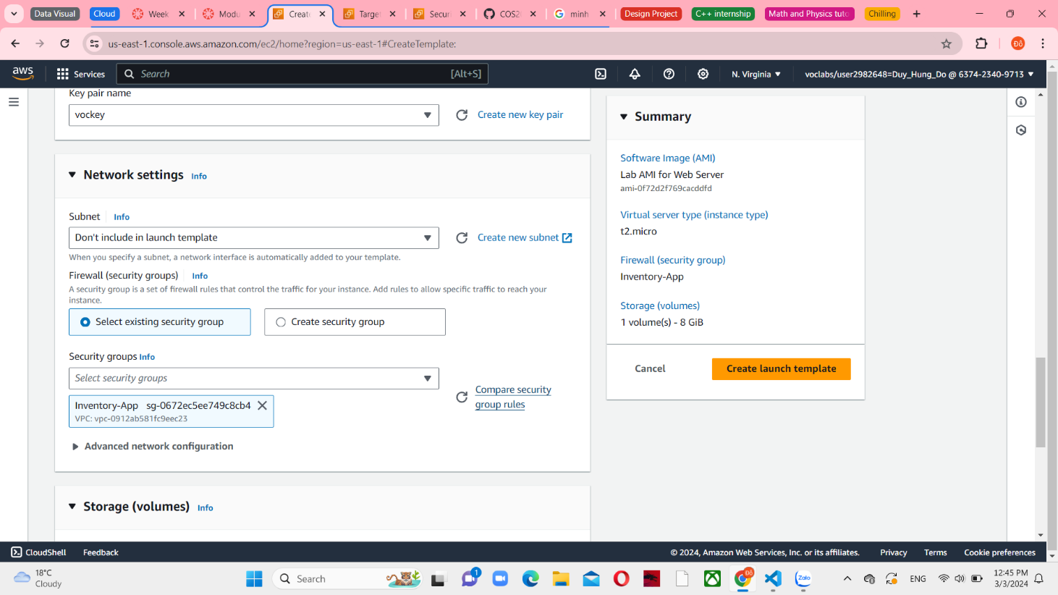

*Figure 32 Network settings*

Expand the Advances details area and choose Inventory-App-Role as an IAM instance profile.

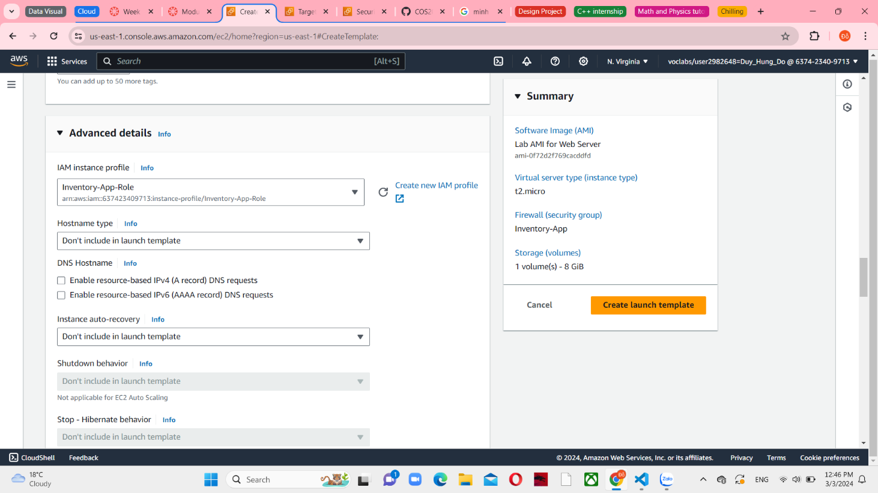

*Figure 33 Advanced details*

Enable the Details CloudWatch monitoring. This will allow Auto Scaling to react quickly to changing utilization.

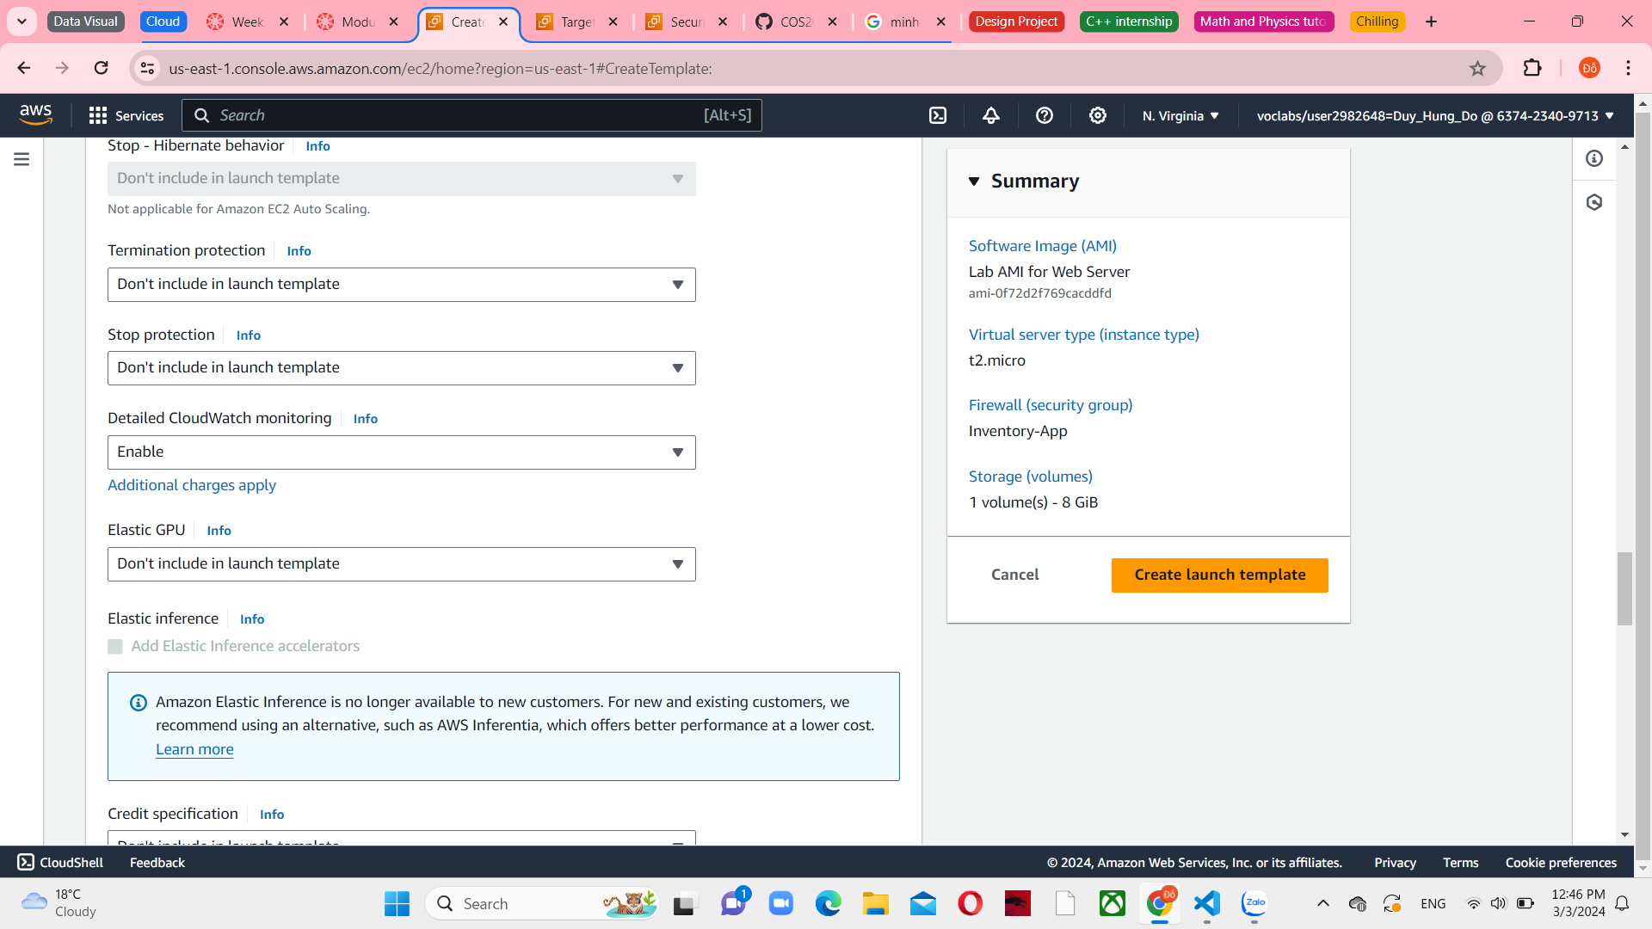

*Figure 34 Advanced details*

Under User data, paste a small script to activate instances

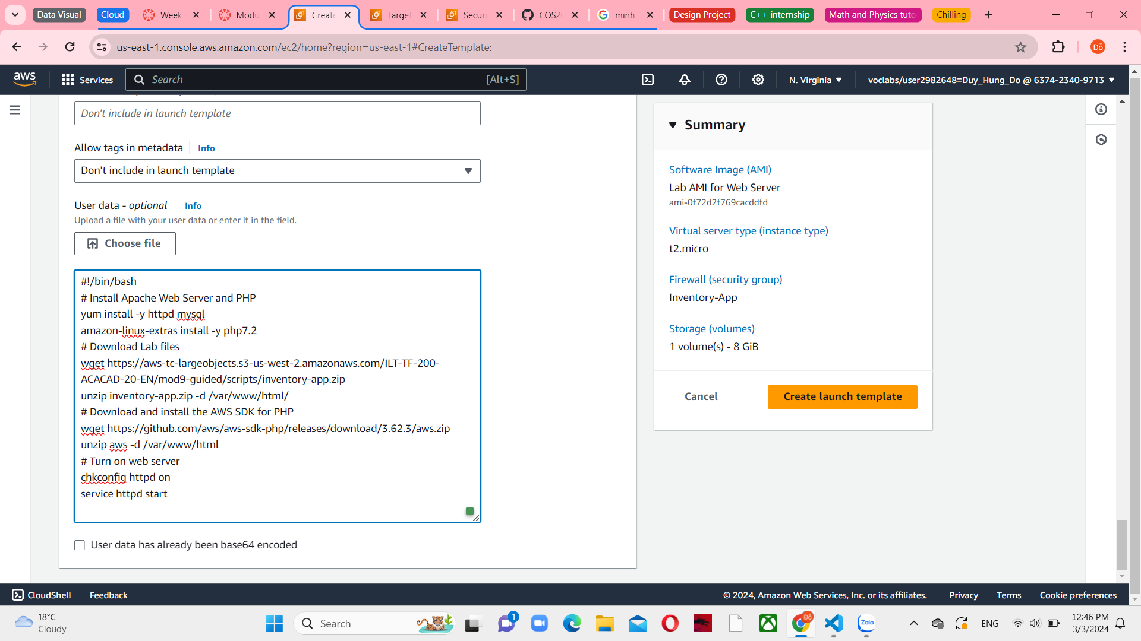

*Figure 35 User data in Advanced details*

Choose Crate launch template. Next, you are going to generate an Auto Scaling group that employs this launch template. The Auto Scaling group specifies the location for launching the EC2 instances.

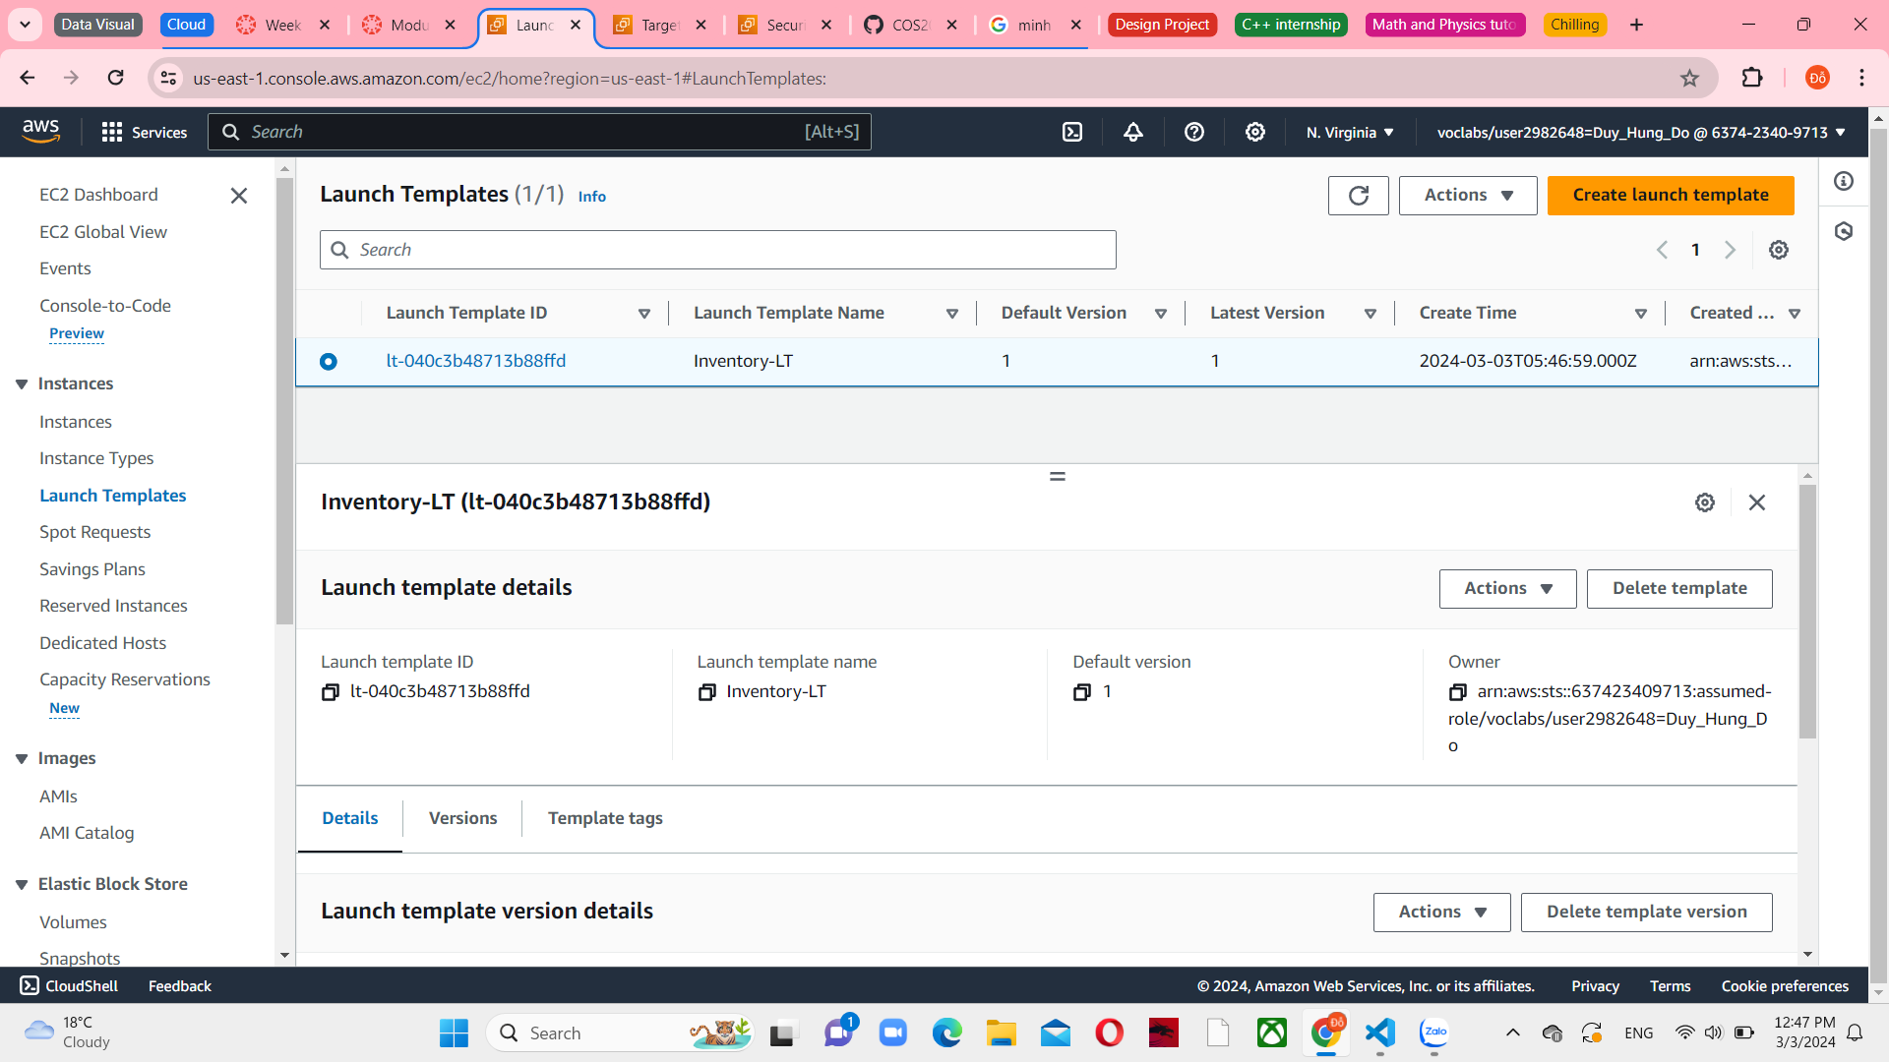

*Figure 36 Inventory-LT details*

Choose it and Create Auto Scaling group from the Actions menu

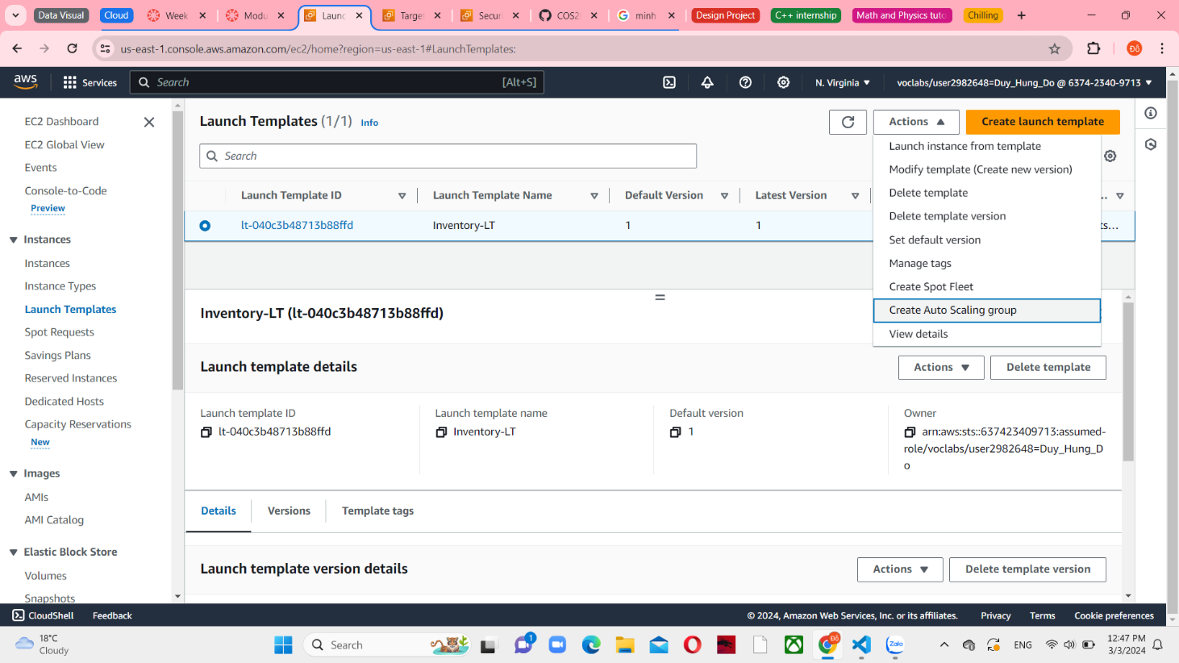

*Figure 37 Create Auto Scaling group in Launch templates*

In step 1, set the Auto Scaling group name is “Inventory-ASG” and connect with Inventory-LT Launch template

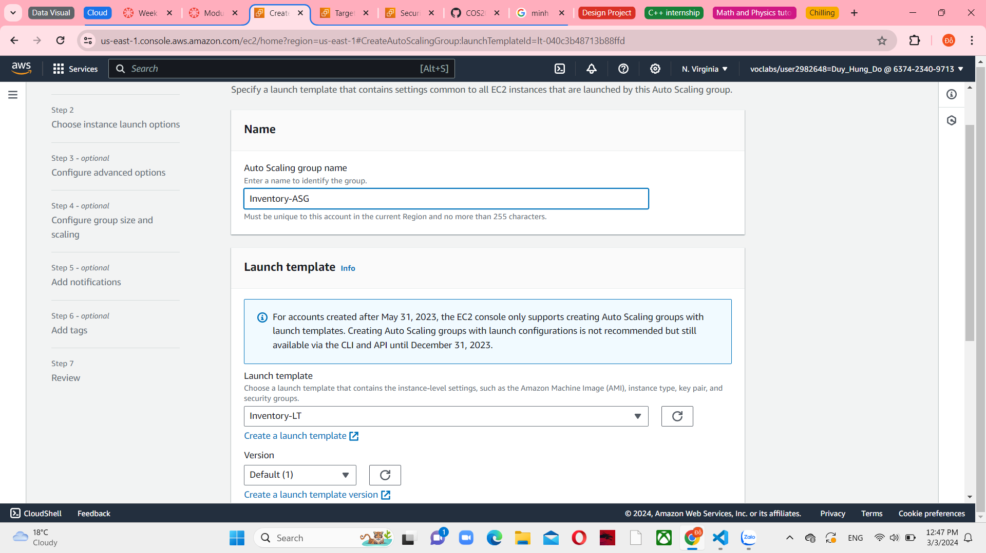

*Figure 38 Choose launch template or configuration*

In step 2, connect with Lab VPC against and 2 Private Subnet for each Availability Zones. This will launch EC2 instances in private subnets across both Availability Zones.

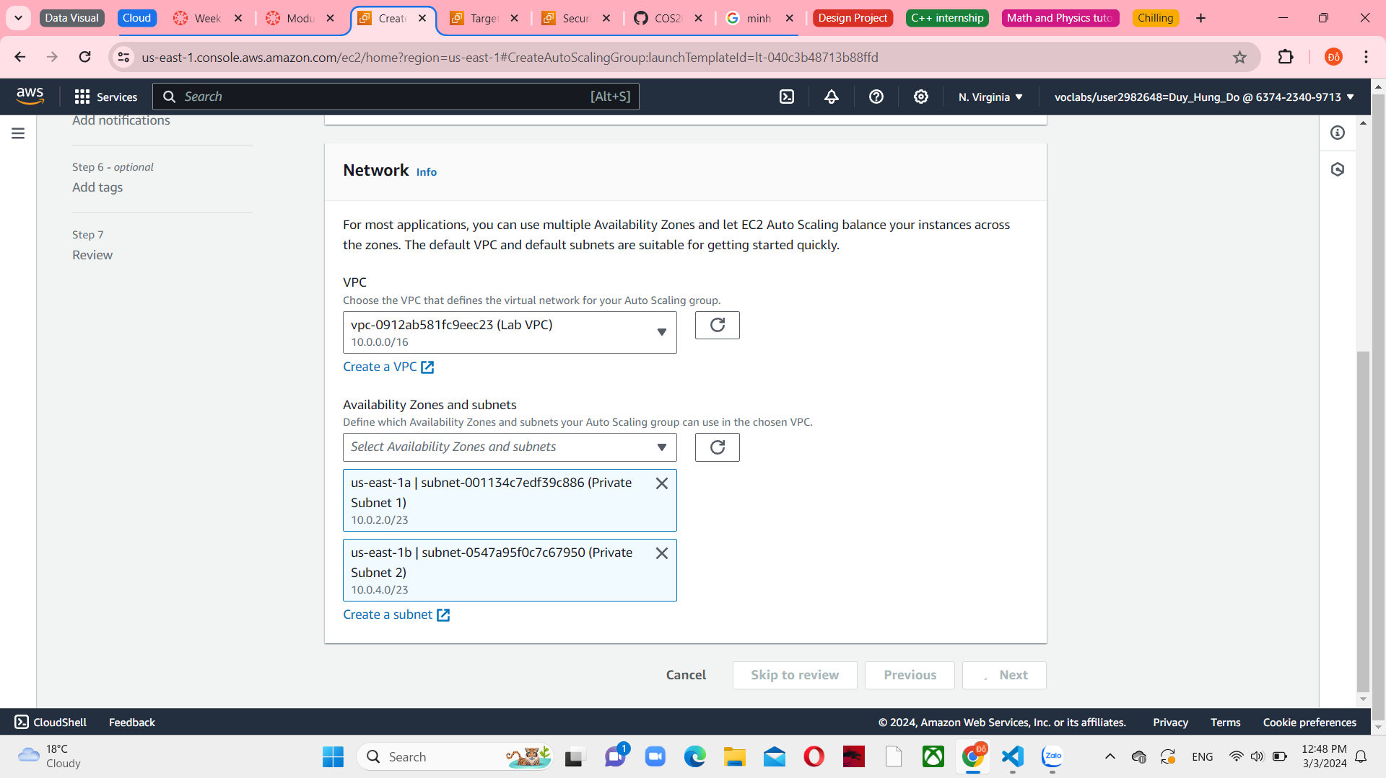

*Figure 39 Choose instance launch options*

In step 3, choose Attach to an existing load balancer in Load balancing panel and connect with Inventory-App as a target group

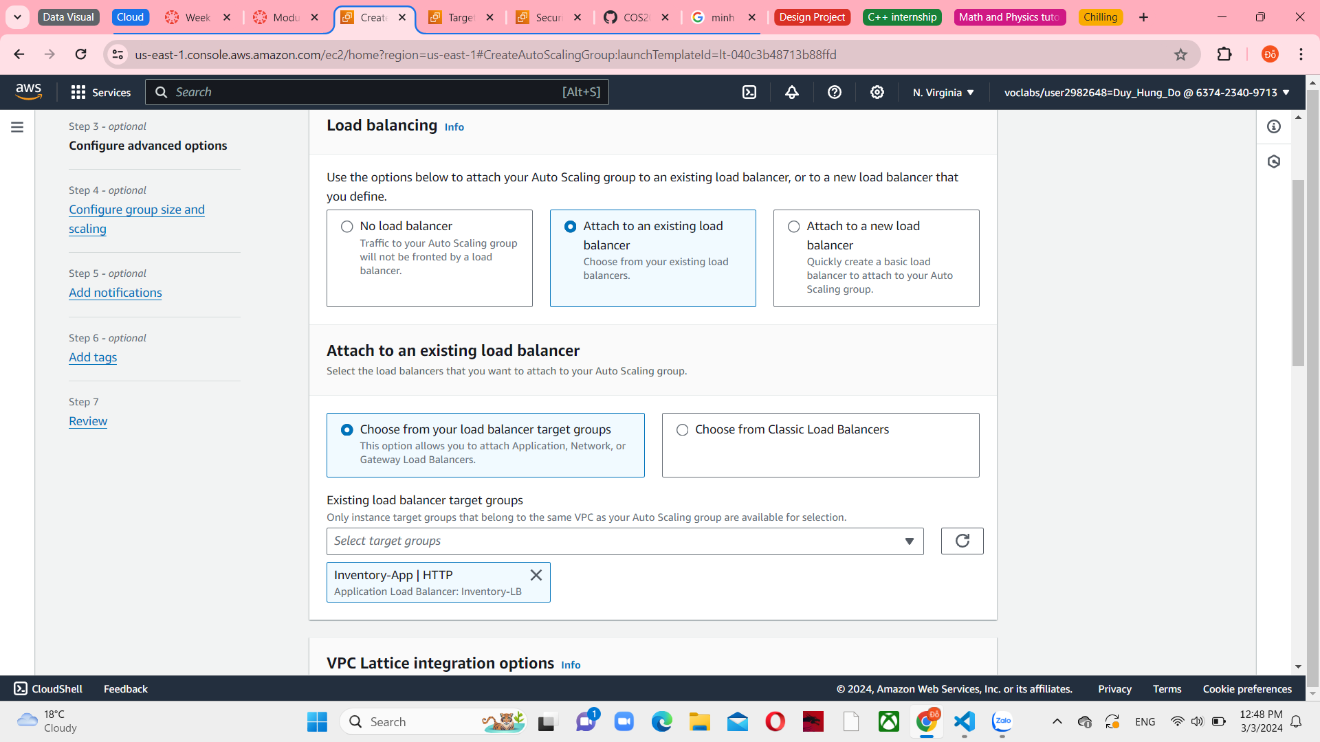

*Figure 40 Load Balancing Configure advanced options*

In the Health checks panel, set the grace period in 90 seconds

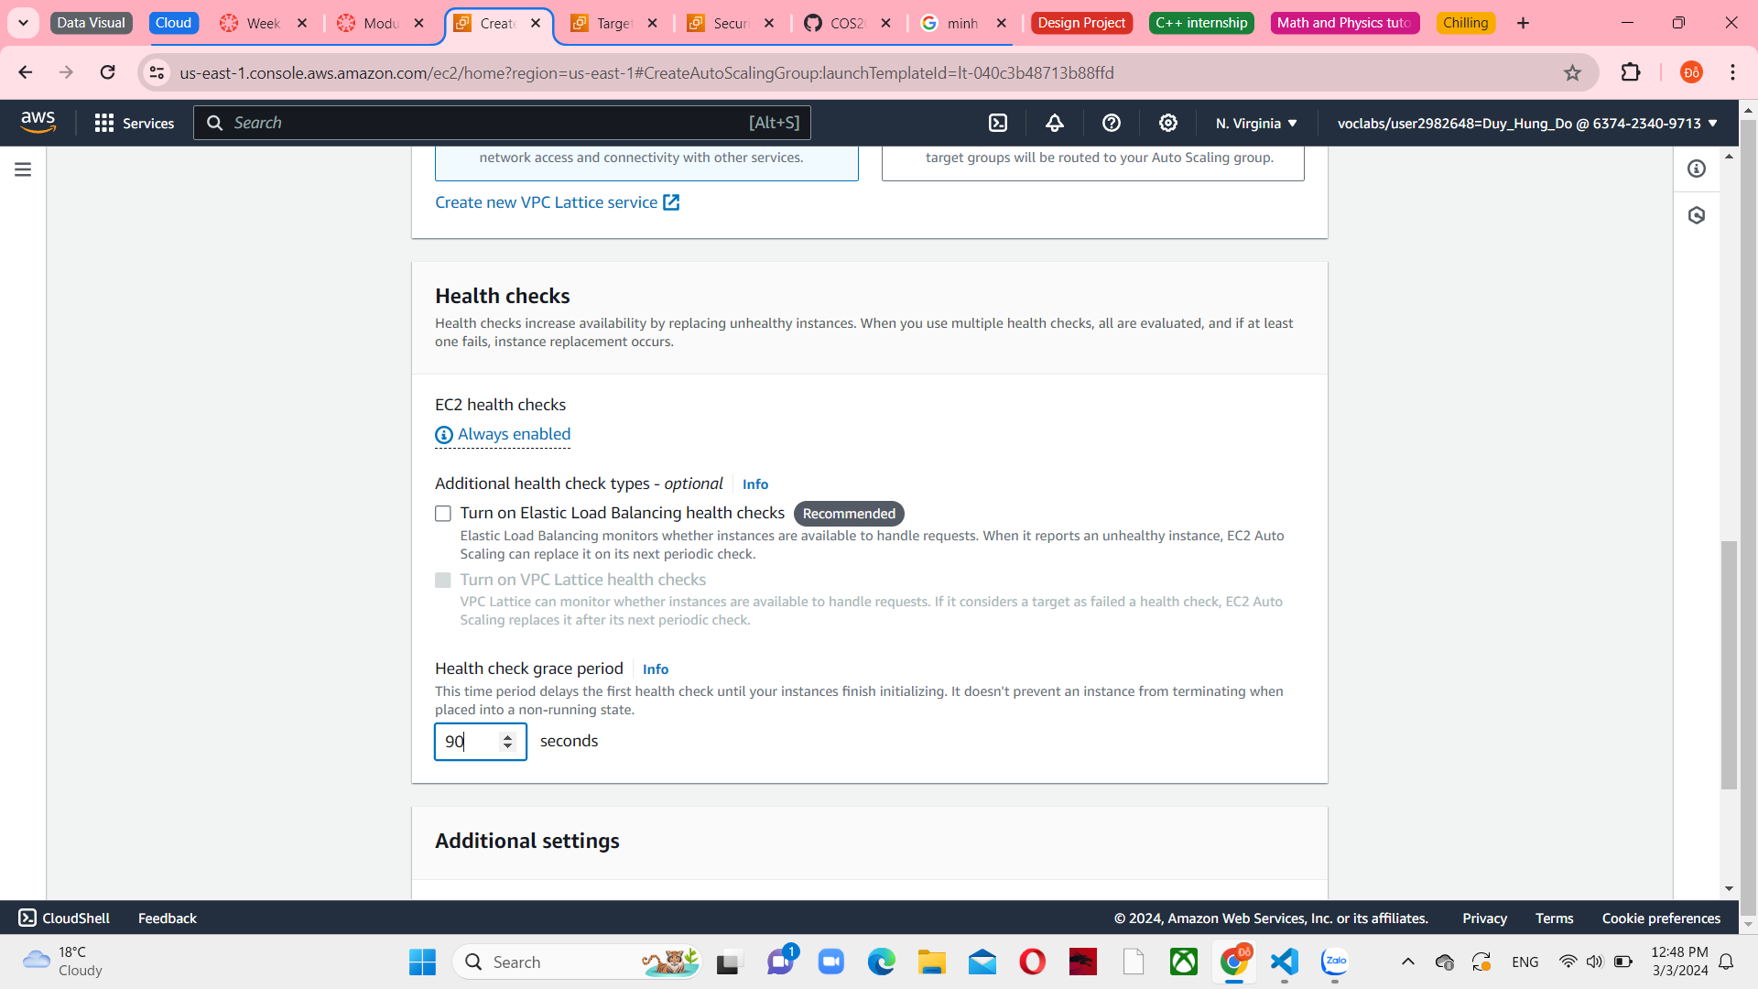

*Figure 41 Health checks in Configure advanced options*

Select Enable group metrics collection within CloudWatch in Additional settings. This will record measurements every minute, enabling Auto Scaling to promptly respond to fluctuations in usage patterns.

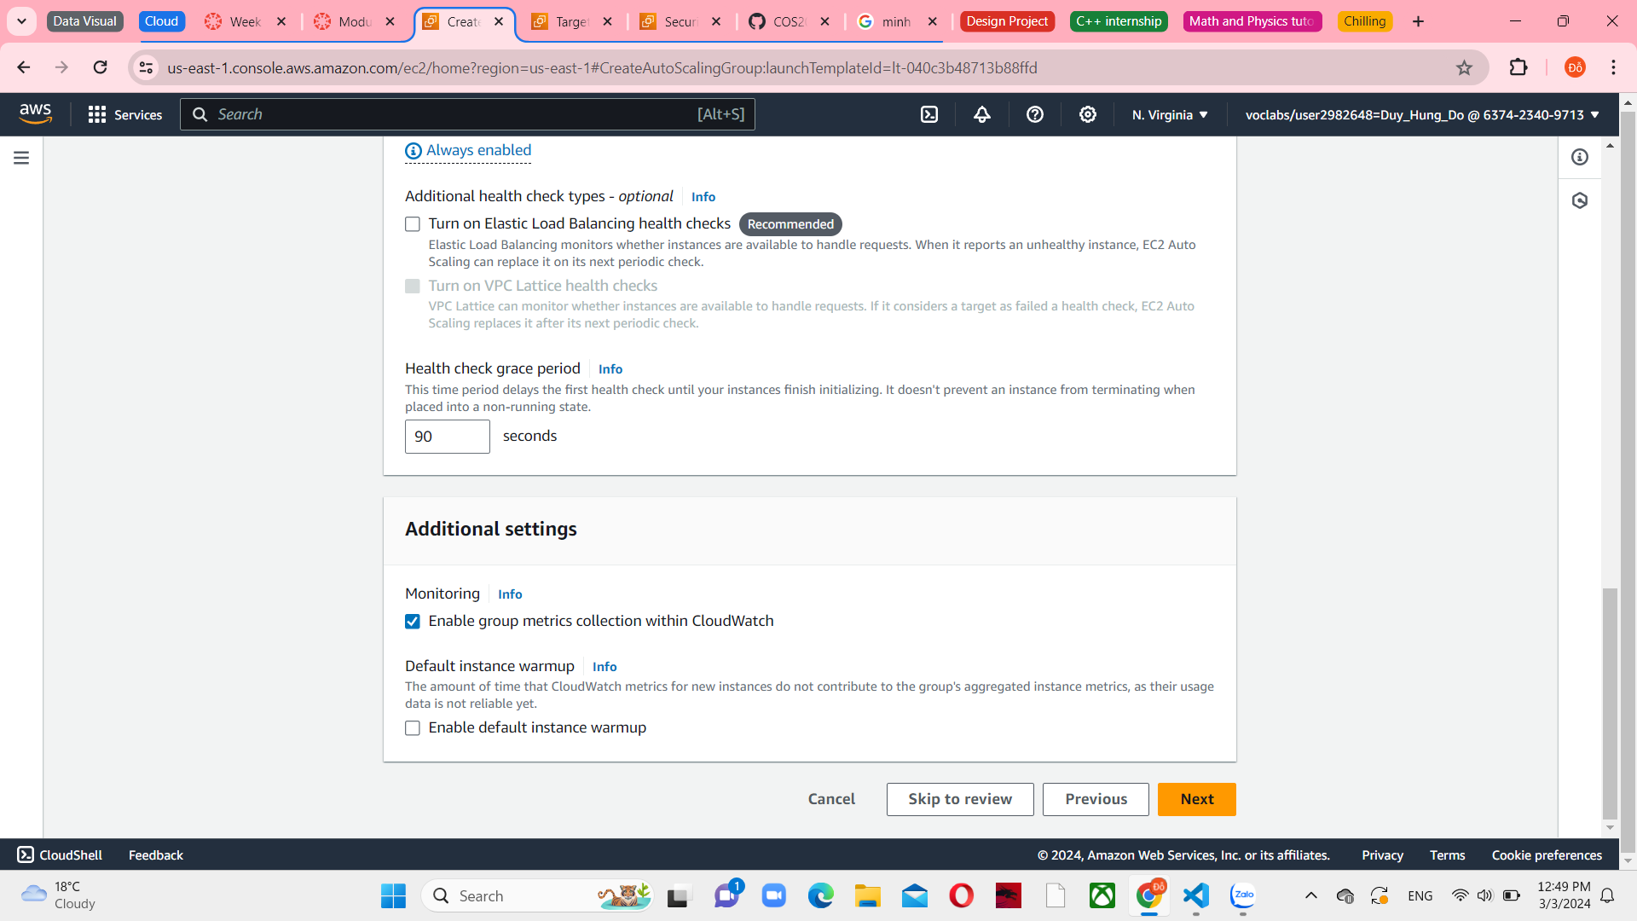

*Figure 42 Additional settings in Configure advanced options*

In step 4, under group size configure the desired capacity, minimum and maximum capacity are 2. This will record measurements every minute, enabling Auto Scaling to promptly respond to fluctuations in usage patterns. And select No scaling policies

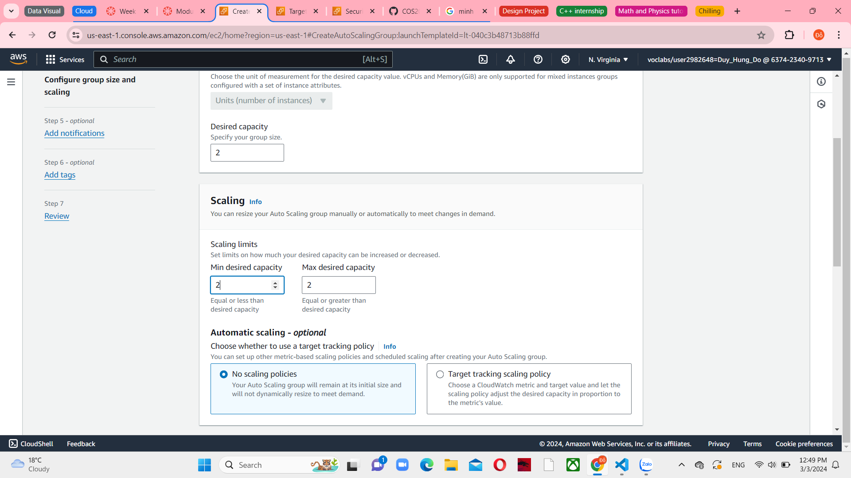

*Figure 43 Configure group size and scaling policies - optional*

In step 5, you do not need to configure any of these settings

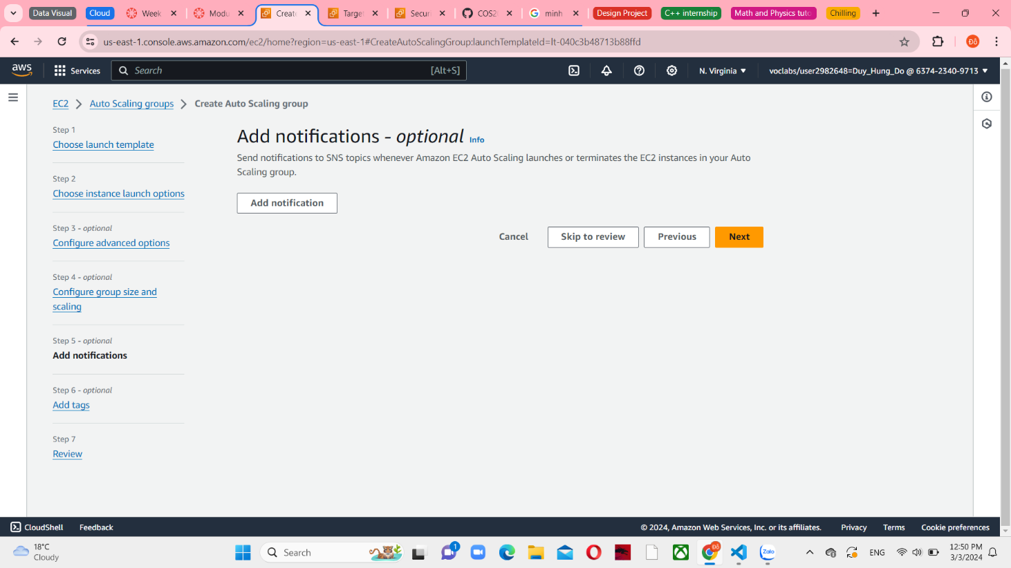

*Figure 44 Add notifications – optional*

In step 6, choose Add tag and set the “Name” as a key and “Inventory-App” as the value. These configurations will label the Auto Scaling group with a Name, which will also be visible on the EC2 instances that are created by the Auto Scaling group. Tags can be utilized to determine which Amazon EC2 instances are linked to which application. Additionally, tags like Cost Center can be included to allocate application expenses in the billing records.

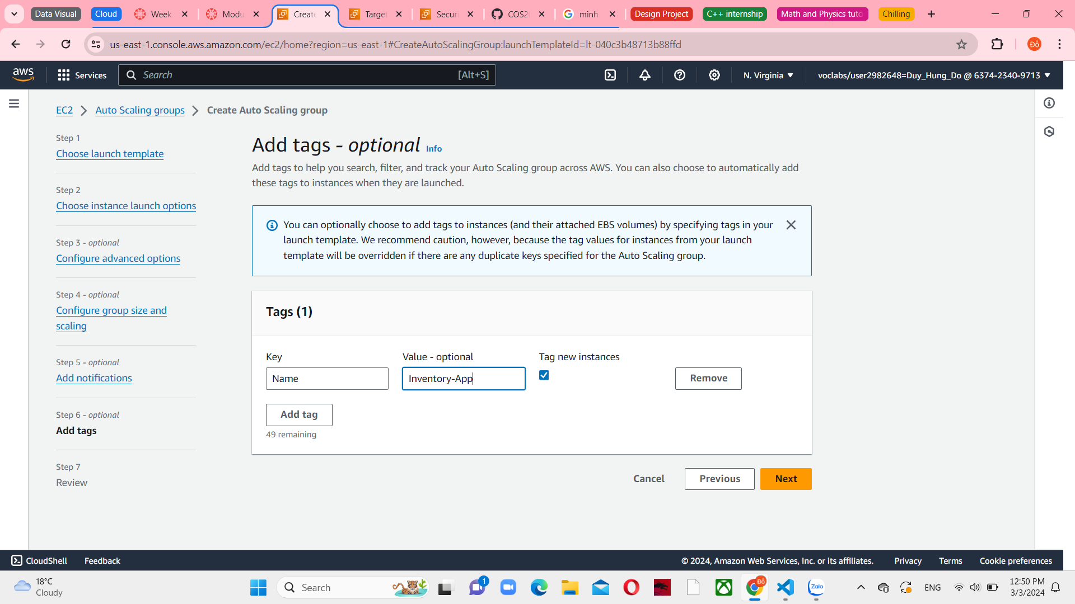

*Figure 45 Add tags - optional*

In step 6, review the details of your Auto Scaling group. And then, choose Create Auto Scaling group

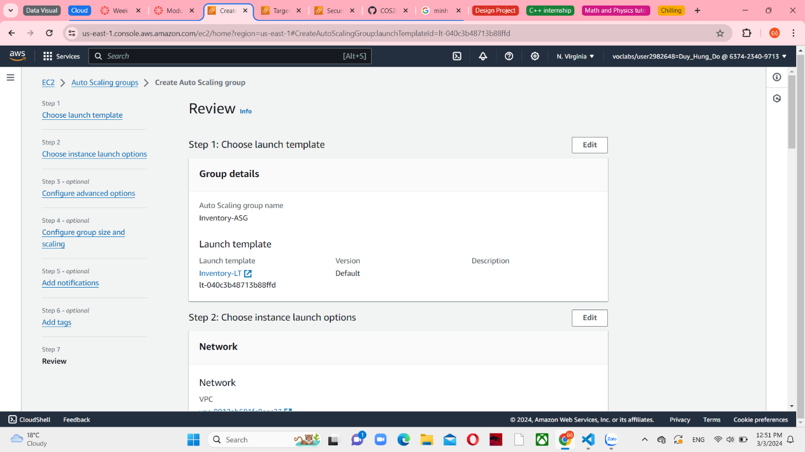

*Figure 46 Review*

After a minute, choose the refresh icon to update the status. It will be changed from updating to running

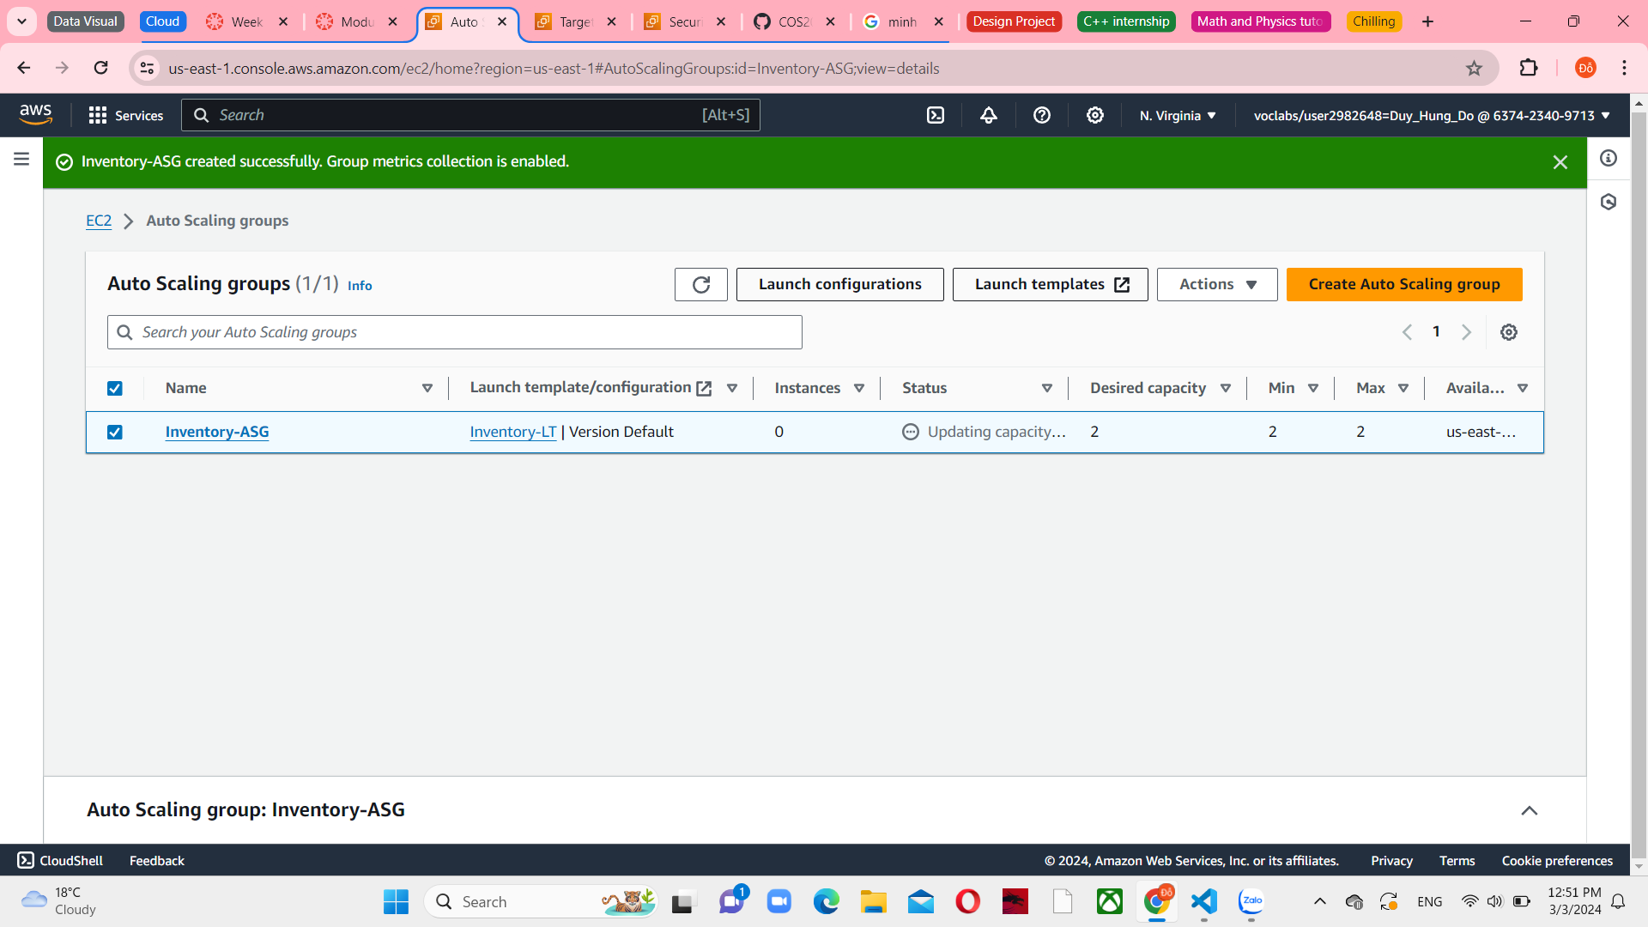

*Figure 47 Create Auto Scaling group successfully*

**Task 4: Updating security groups**

Choose Security Groups in the left navigation pane, and select Inventory-App. You can see the Inbound rules of its

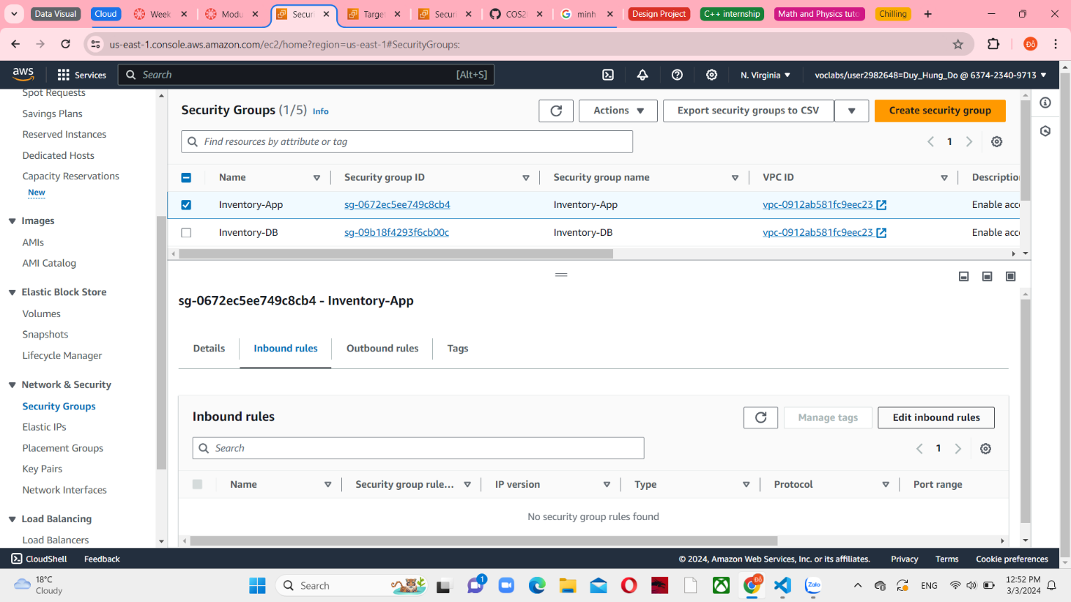

*Figure 48 Inventory-App inbound rules*

Choose Edit inbound rules, add the HTTP types with an Inventory-LB source. The description is Traffic from load balancer

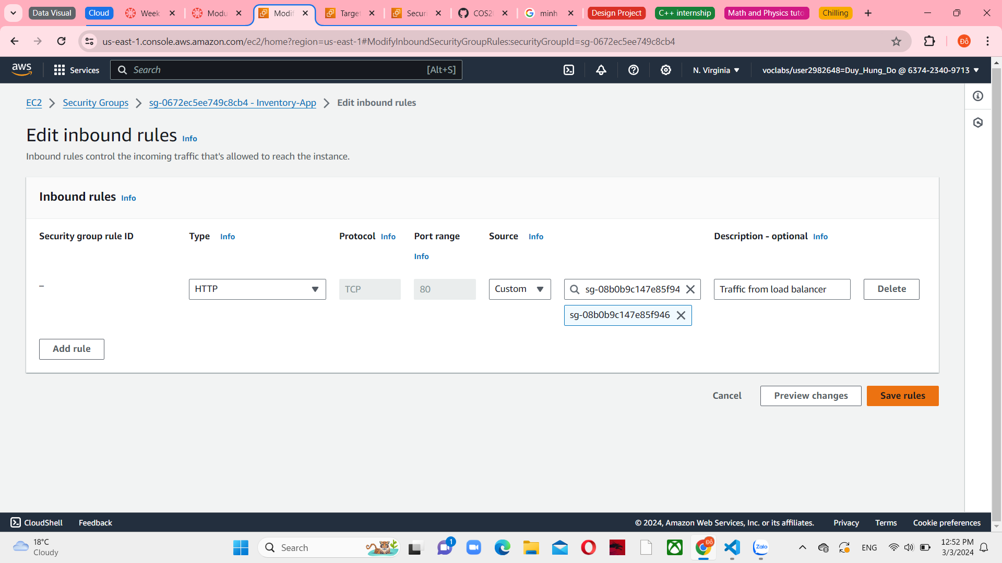

*Figure 49 Edit inbound rules in Inventory-App*

In the Security groups list, choose Inventory-DB and deselect Inventory-App. The existing rule permits traffic on port 3306 (used by MySQL) from any IP address within the VPC. This is a good rule, but security can be restricted further.

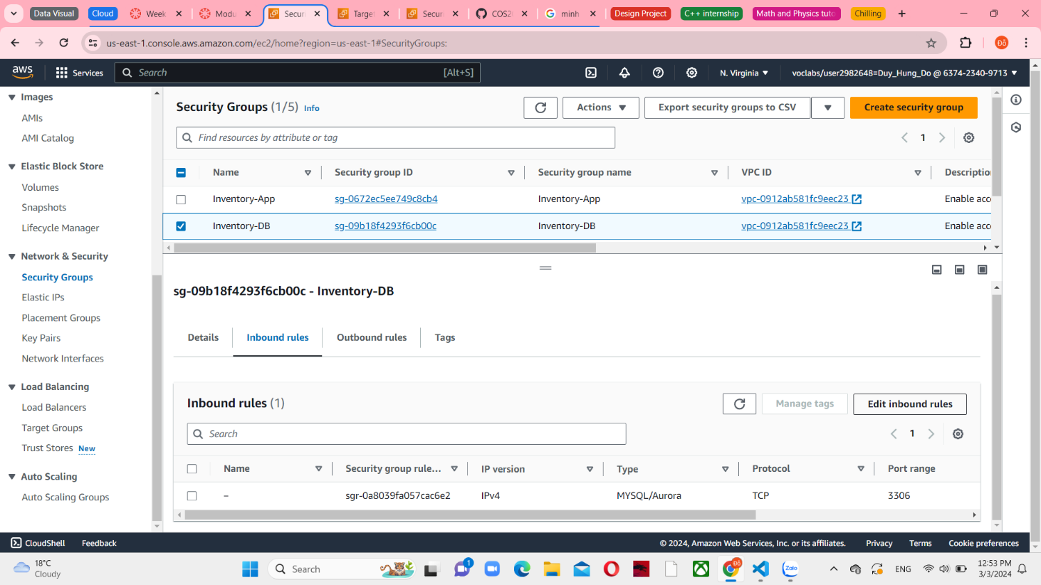

*Figure 50 Inventory-DB inbound rules*

Choose Edit inbound rules. Delete the existing rule and add the MYSQL/Aurora type with Inventory-App source. The description is Traffic from application servers.

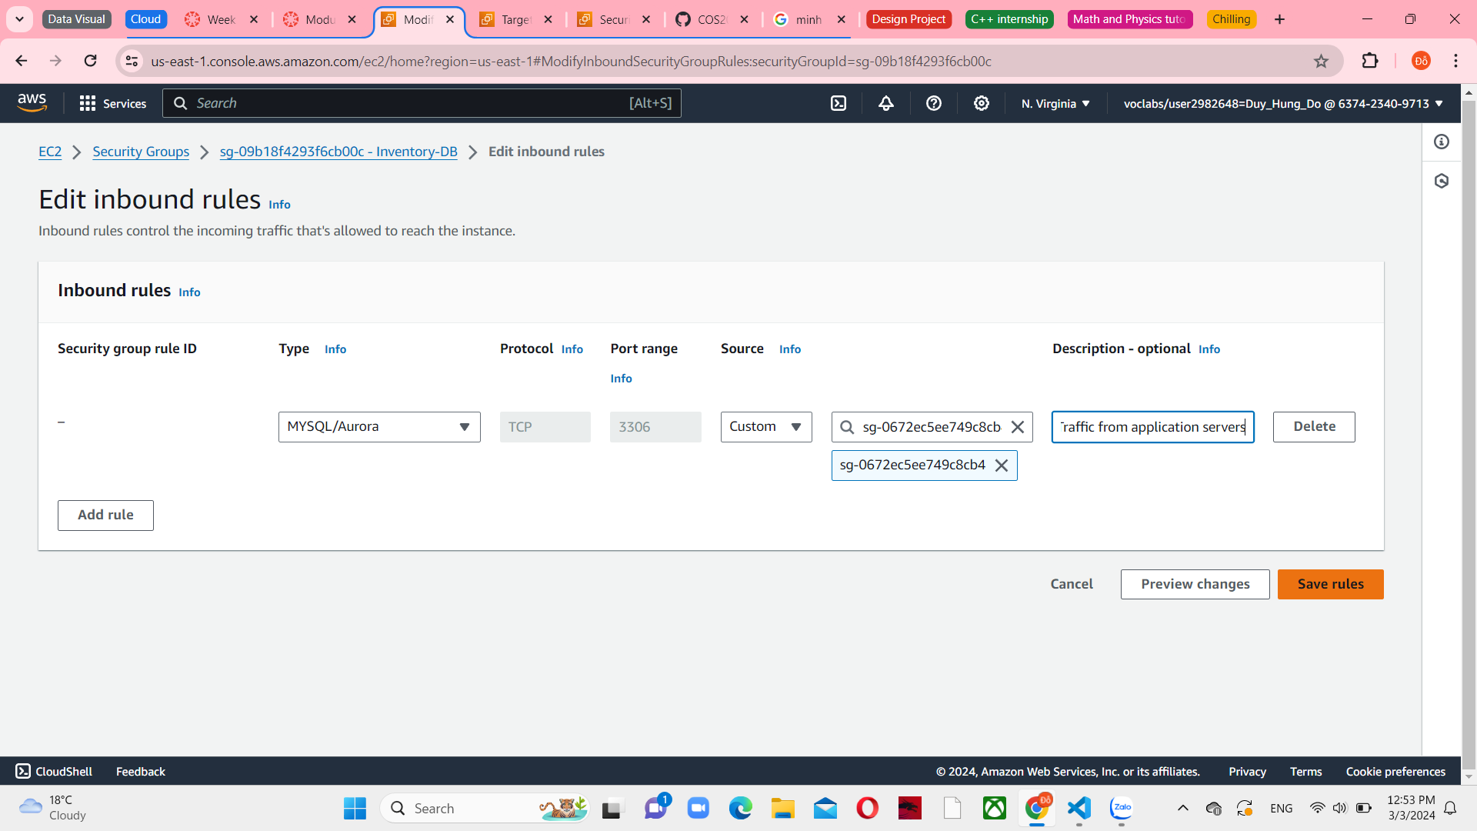

*Figure 51 Edit inbound rules in Inventory-DB*

**Task 5: Testing the application**

In the left navigation pane, choose Target Groups and select Inventory-App. You can see the Targets tab show the Health status in 2 Inventory-App are healthy.

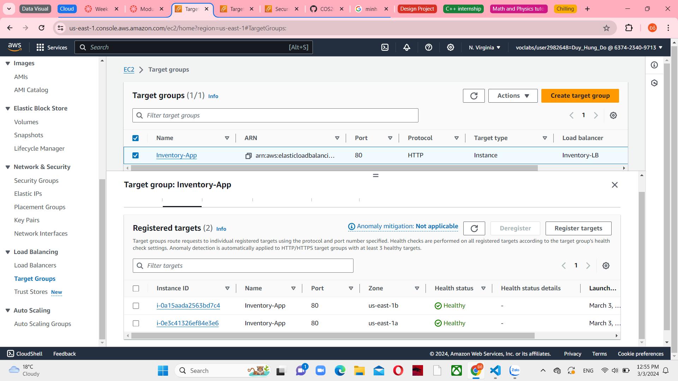

*Figure 52 Registered targets in Inventory-App*

Return to Load Balancers and select Inventory-LB. In the Details tab, copy the DNS name and paste it to another web browser and press Enter.

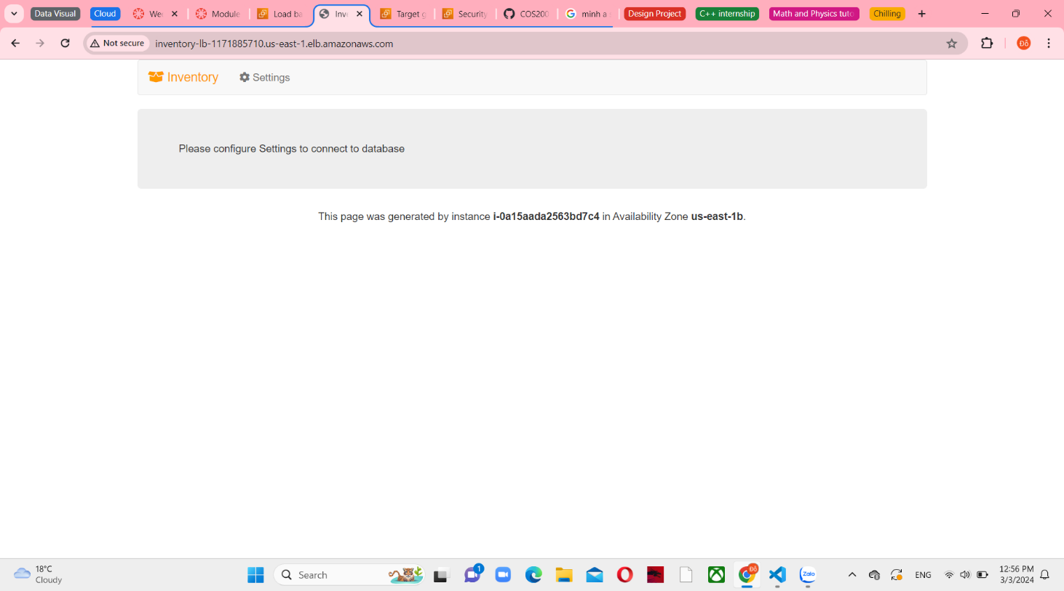

*Figure 53 Web application displays*

**Task 6: Testing high availability**

Return to Instances tab, select one of the Inventory-App to terminate it in Instance State

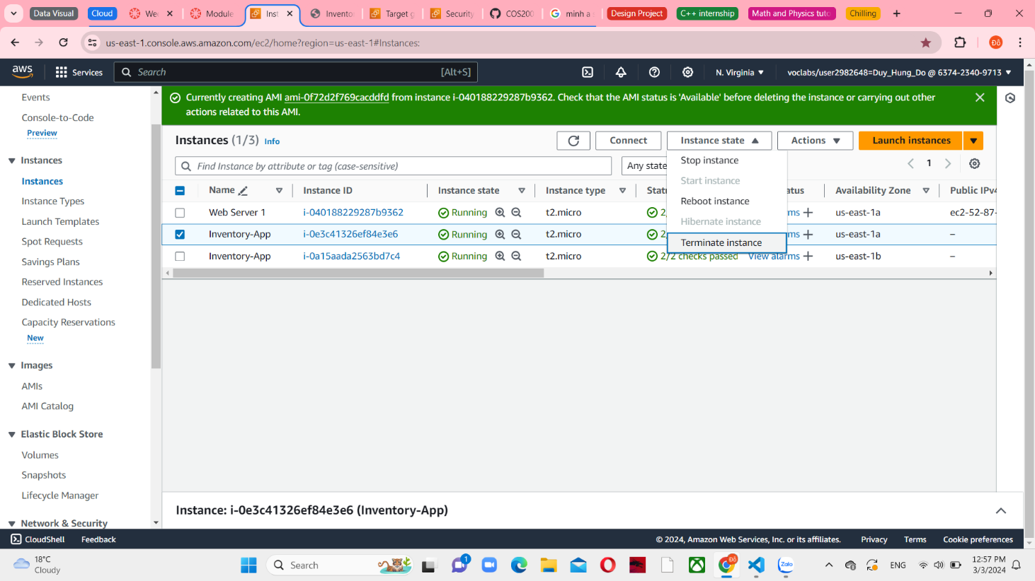

*Figure 54 Terminate Inventory-App*

After a few minutes, Amazon EC2 Auto Scaling will detect the instance failure. It was set up to keep two instances operating, thus Amazon EC2 Auto Scaling will launch a replacement instance.

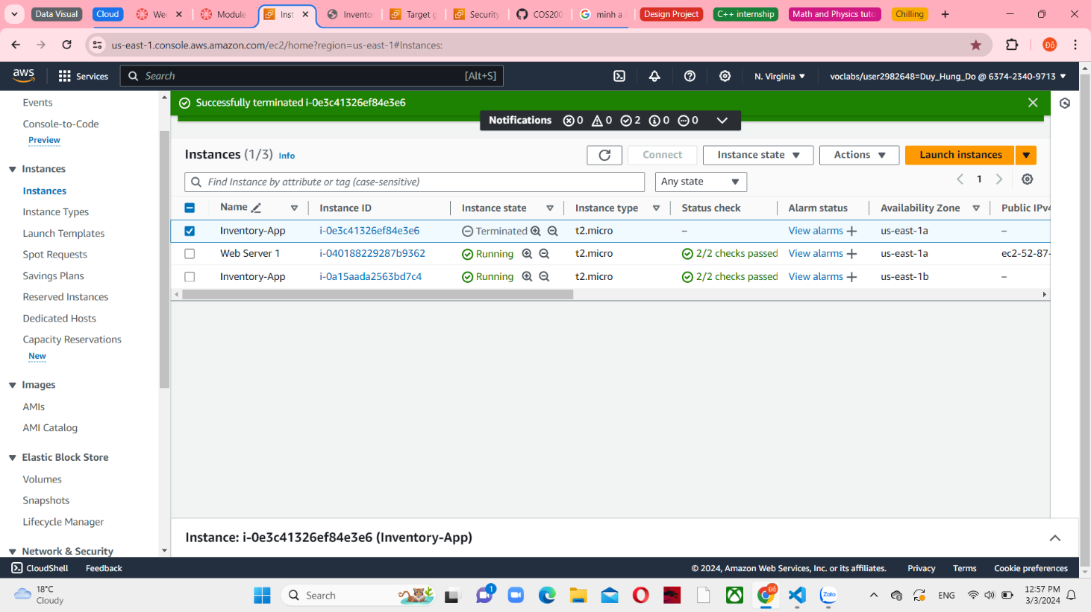

*Figure 55 Successfully terminated*

**Optional task 1: Making the database highly available**

Choose RDS from Services menu and then select Databases in the left navigation pane.

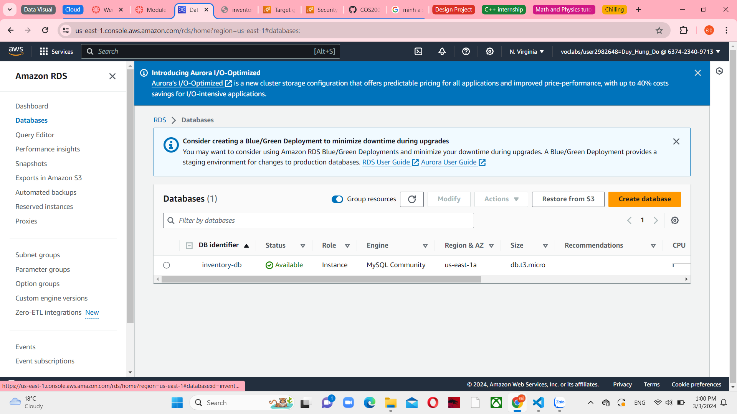

*Figure 56 Databases console*

Choose the inventory-db and modify it.

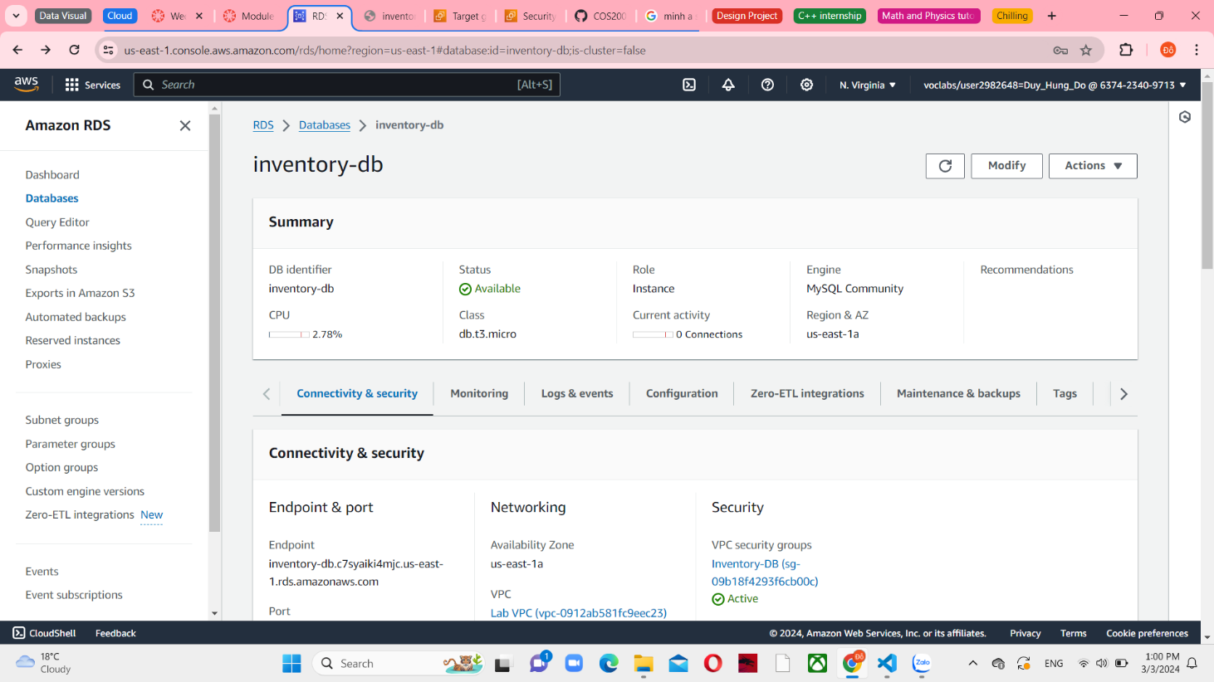

*Figure 57 inventory-db details*

You can see the Availability & durability section. Select Create a standby instance from Multi-AZ deployment. You only need to reconfigure this one setting to convert the database to run across multiple data centers (Availability Zones).

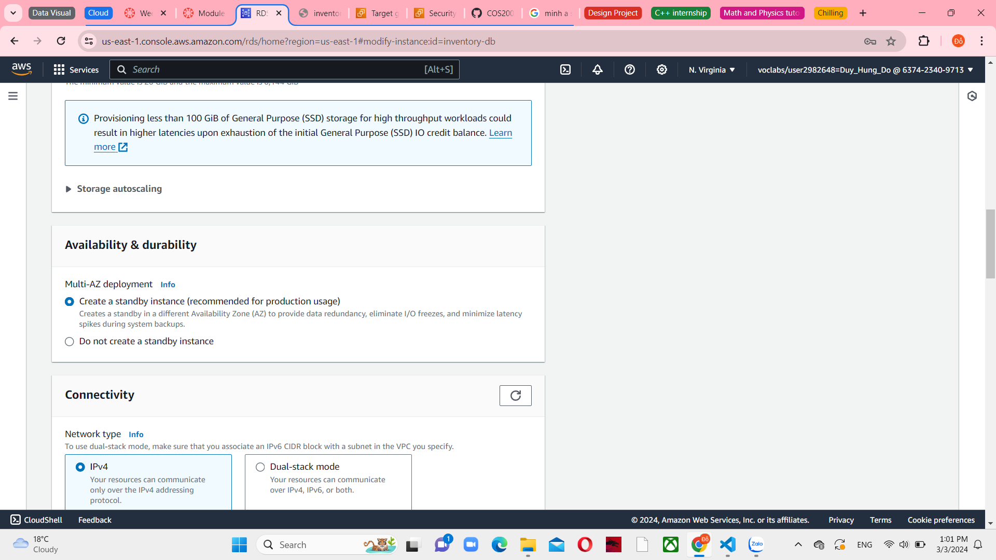

*Figure 58 Availability & durability*

Scroll back up and select db.t3.small in instance class. This action doubles the size of the instance.

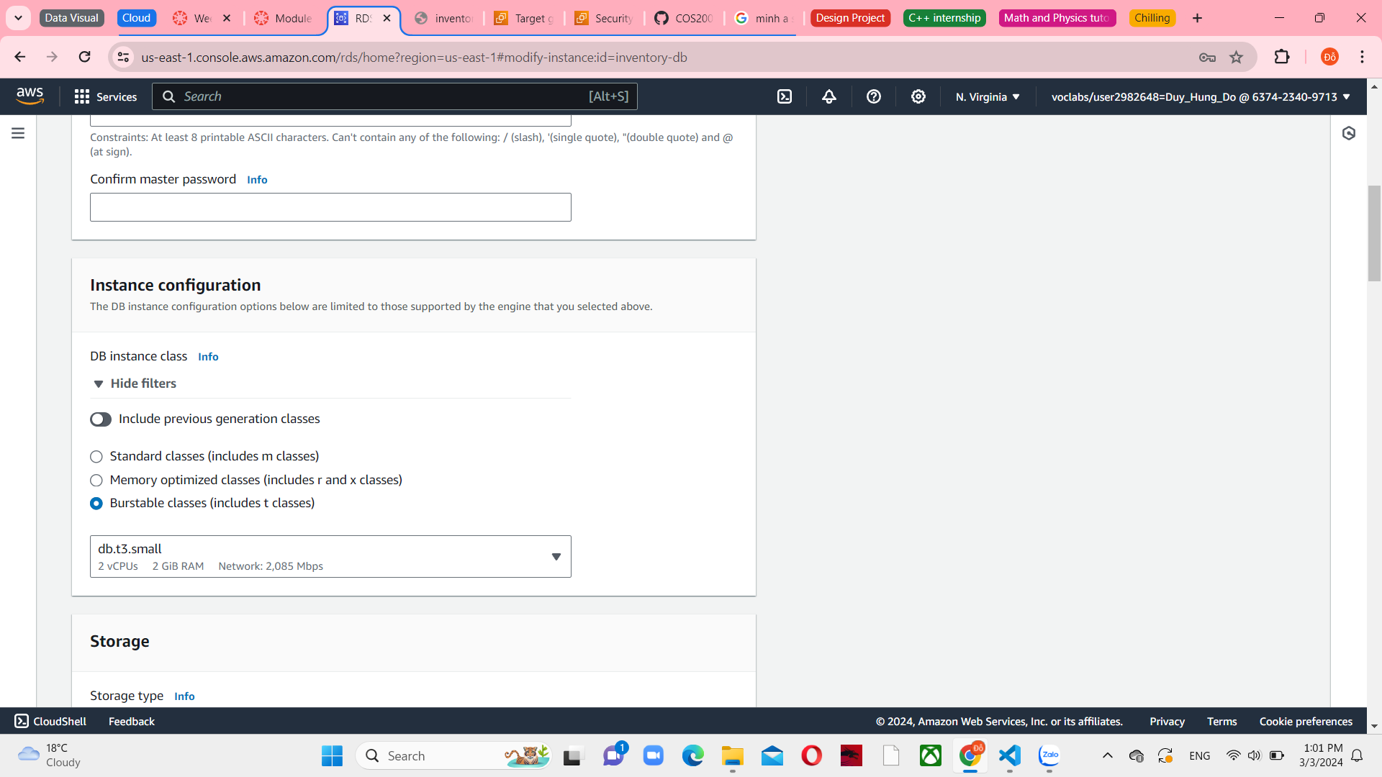

*Figure 59 Instance configuration*

Enter 10 in Allocated storage. This action doubles the database’s allocated space.

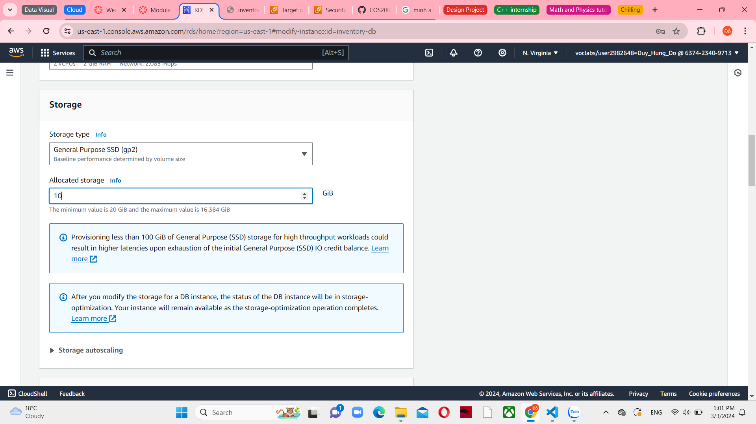

*Figure 60 Doubled storage*

Choose Continue. Database performance will be impacted by these changes. Therefore, these changes can be scheduled during a defined maintenance window, or they can be run immediately. Select Apply immediately in Schedule modifications

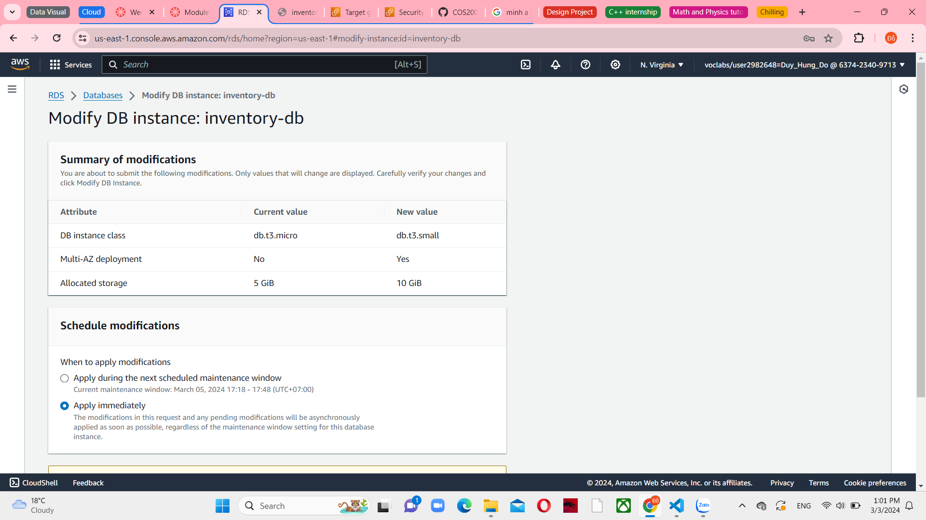

*Figure 61 Summary of modifications*

Choose Modify DB instance. The database enters a modifying state while it applies the changes

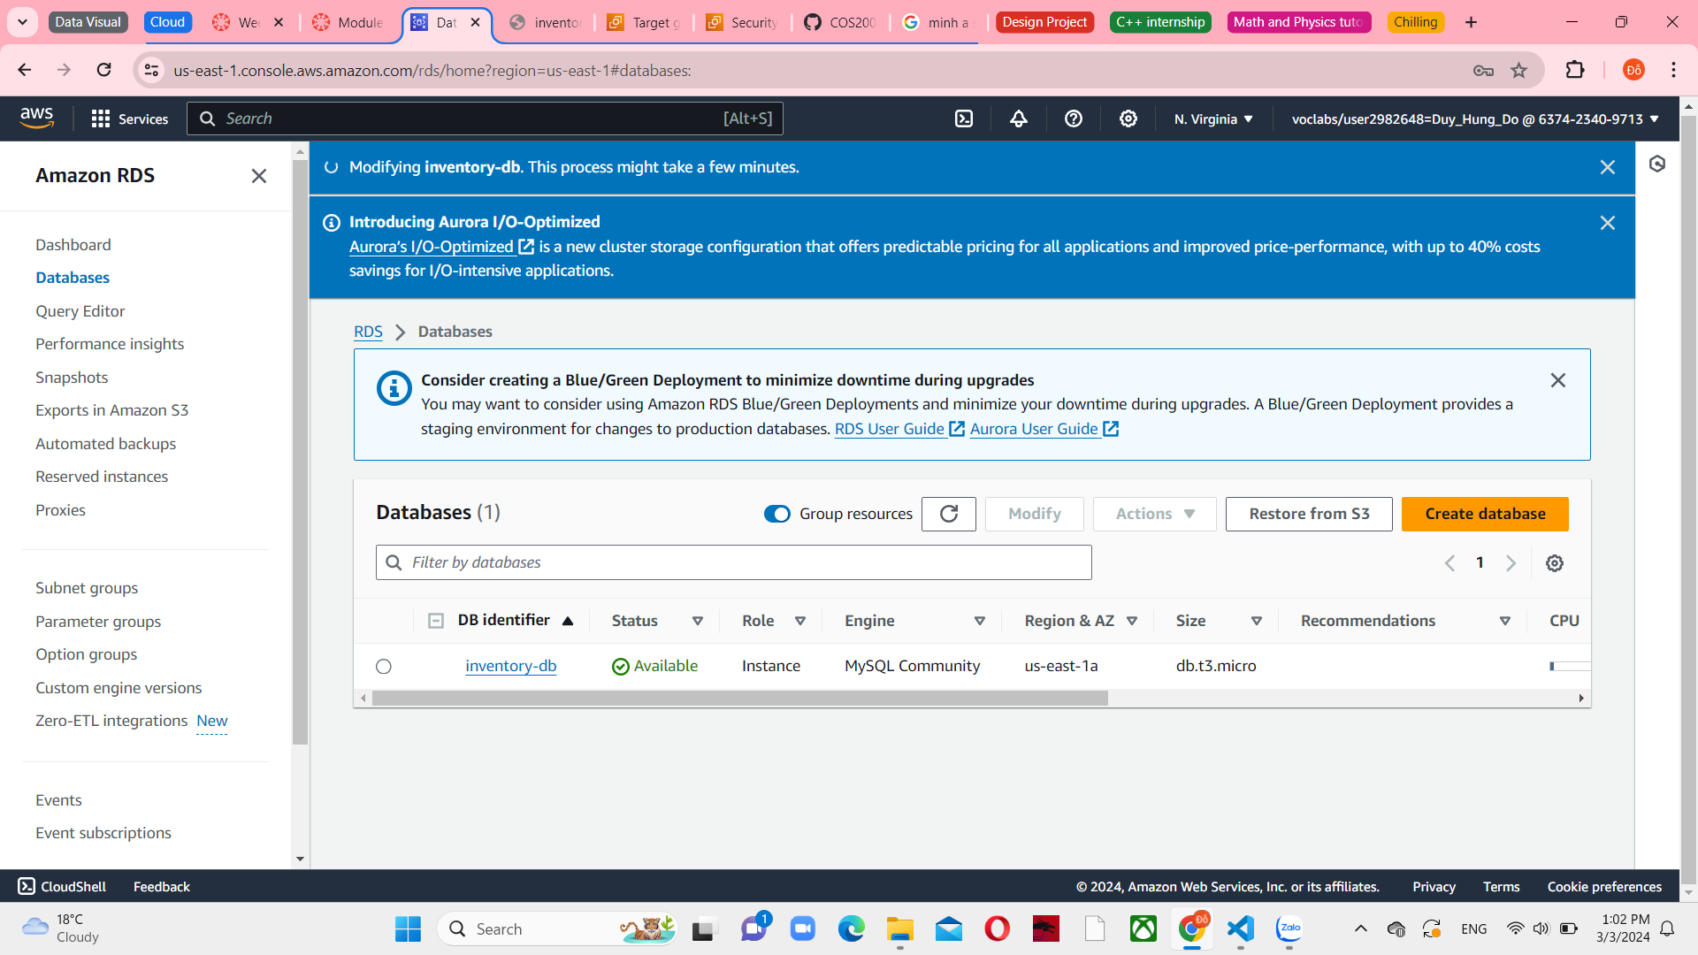

*Figure 62 Modifying inventory-db*

**Optional task 2: Configuring a highly available NAT gateway**

Choose VPC from the Services menu. Select NAT gateways in the left navigation pane, and then create the new one.

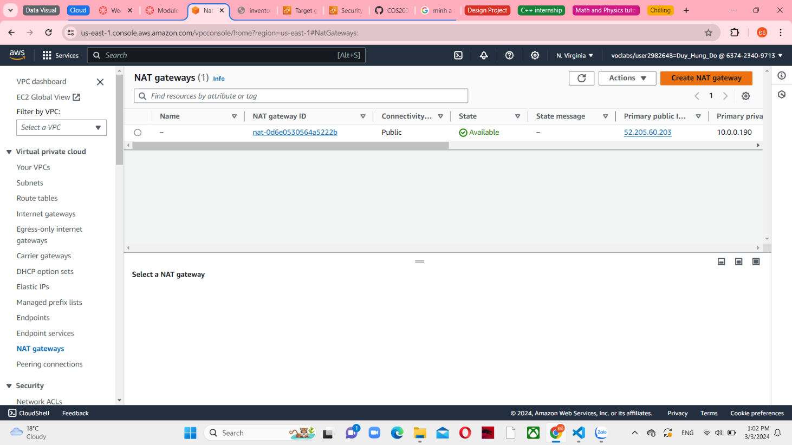

*Figure 63 NAT gateways console*

Configure the name is Public Subnet 2 and Allocate Elastic IP.

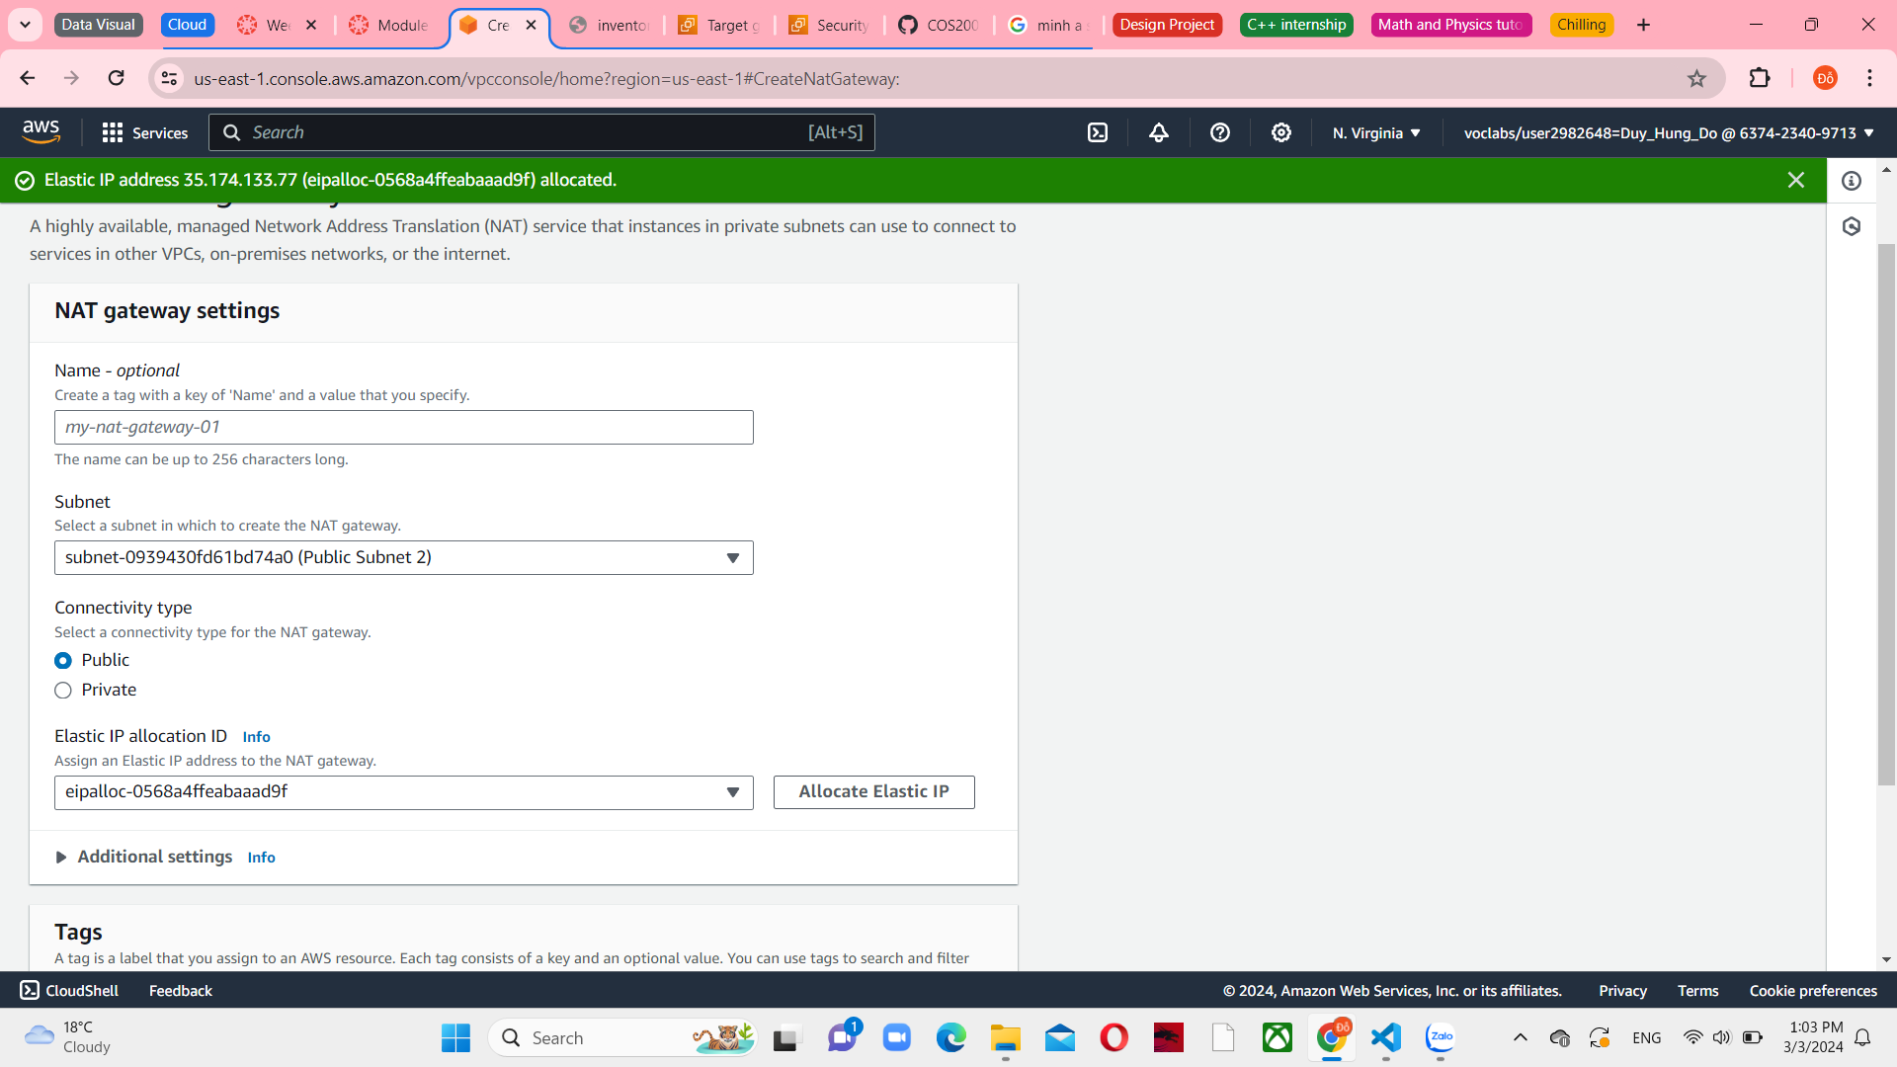

*Figure 64 NAT gateway settings*

After that, create it. You will now create a new route table for Private Subnet 2. This route table will redirect traffic to the new NAT gateway.

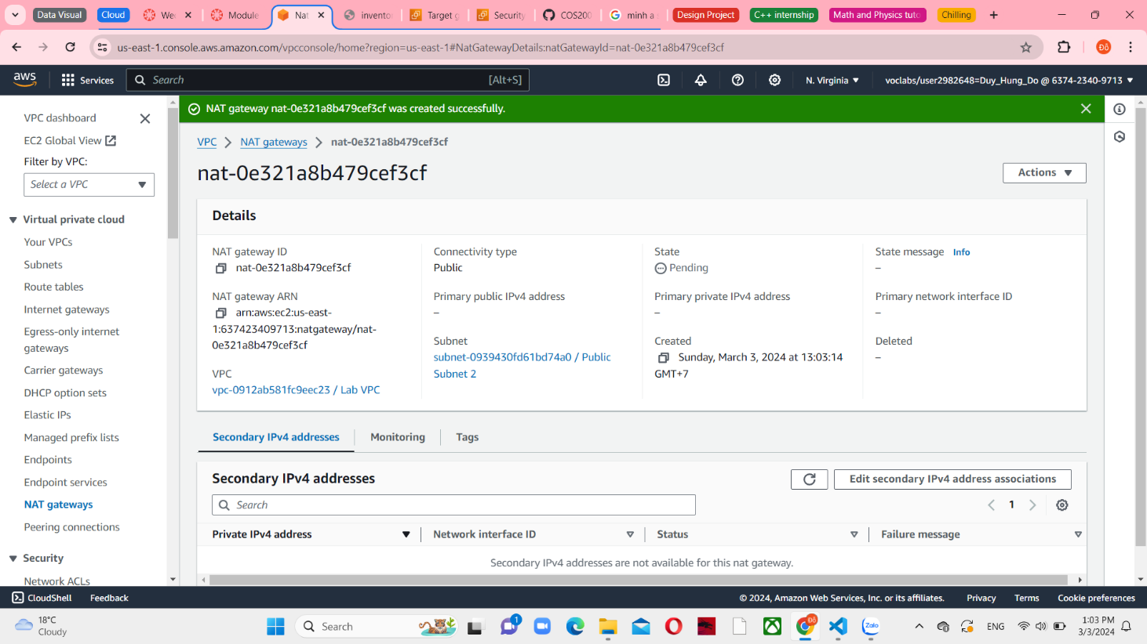

*Figure 65 Create NAT gateway successfully*

In the left navigation pane, choose Route tables. And then create the new one

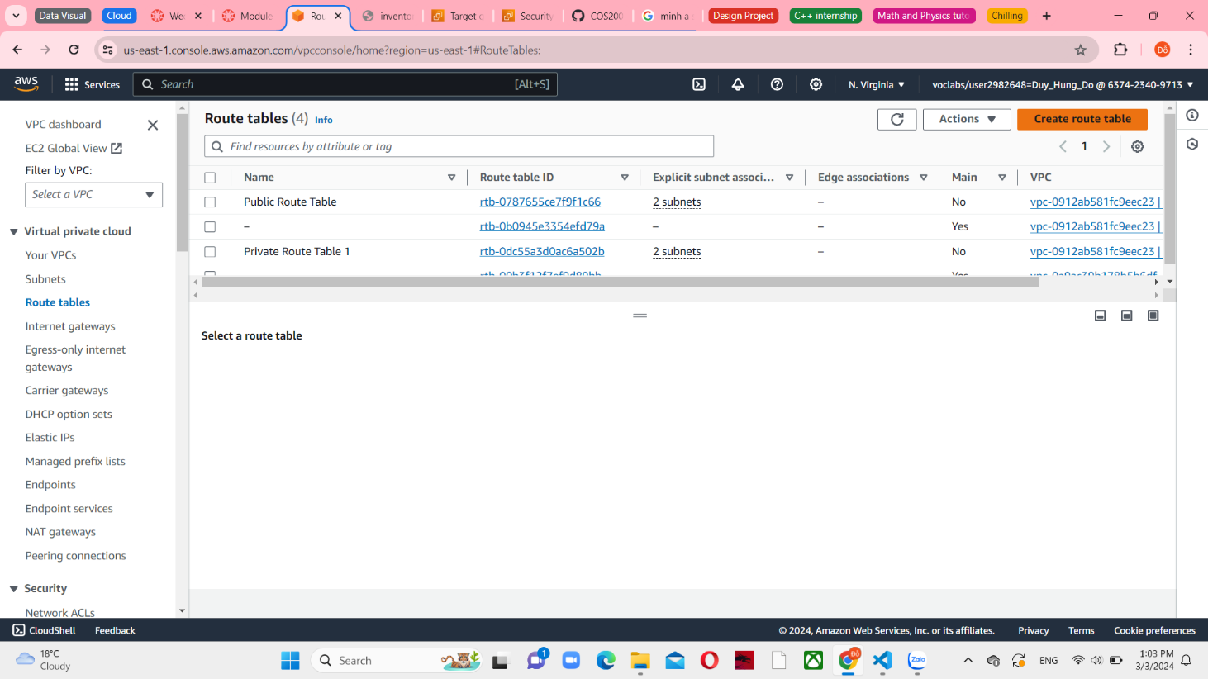

*Figure 66 Route tables console*

Configure the name is Private Route Table 2 and connect with Lab VPC.

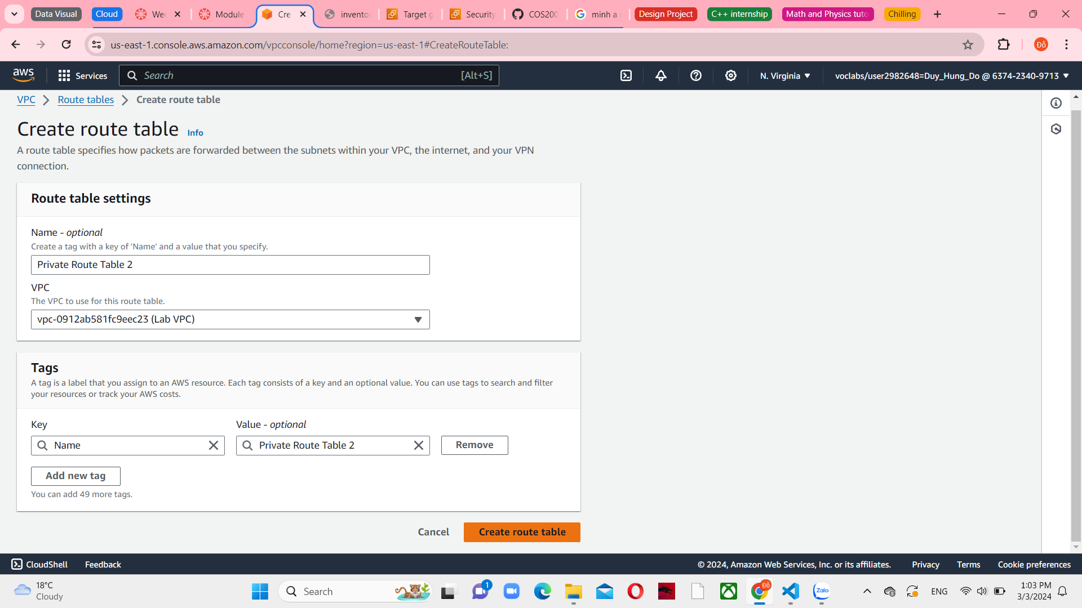

*Figure 67 Create route table*

After that, choose Create route table and you can see a successful message

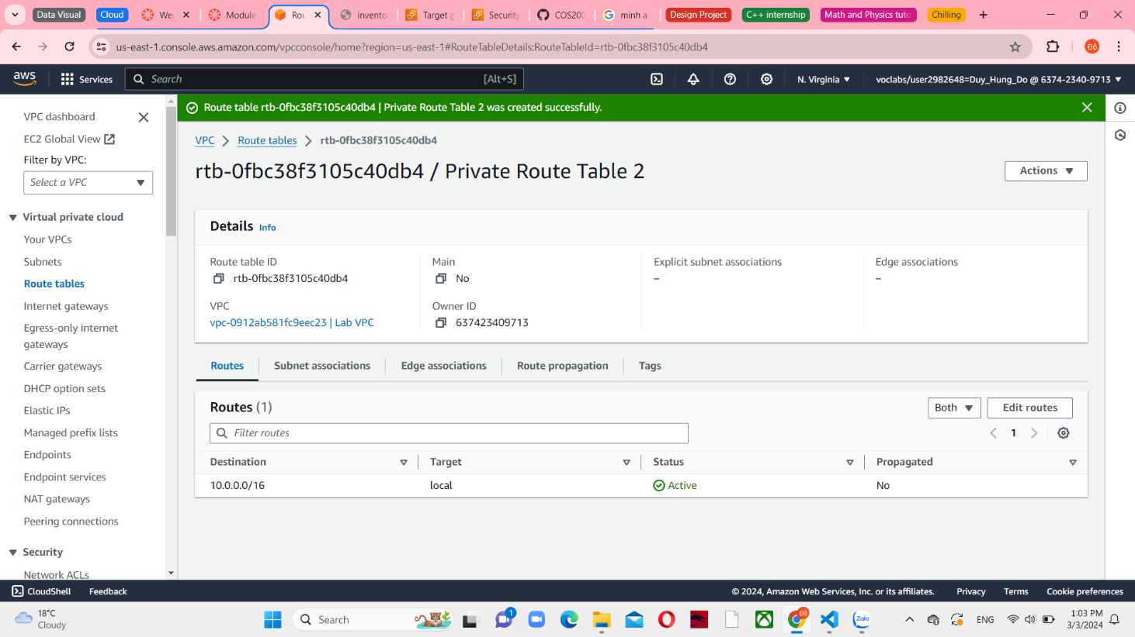

*Figure 68 Create route table successfully*

Click Route tables against and review the Routes tab. Currently, one route directs all local traffic. You will now add a route that sends internet-bound traffic through the new NAT gateway.

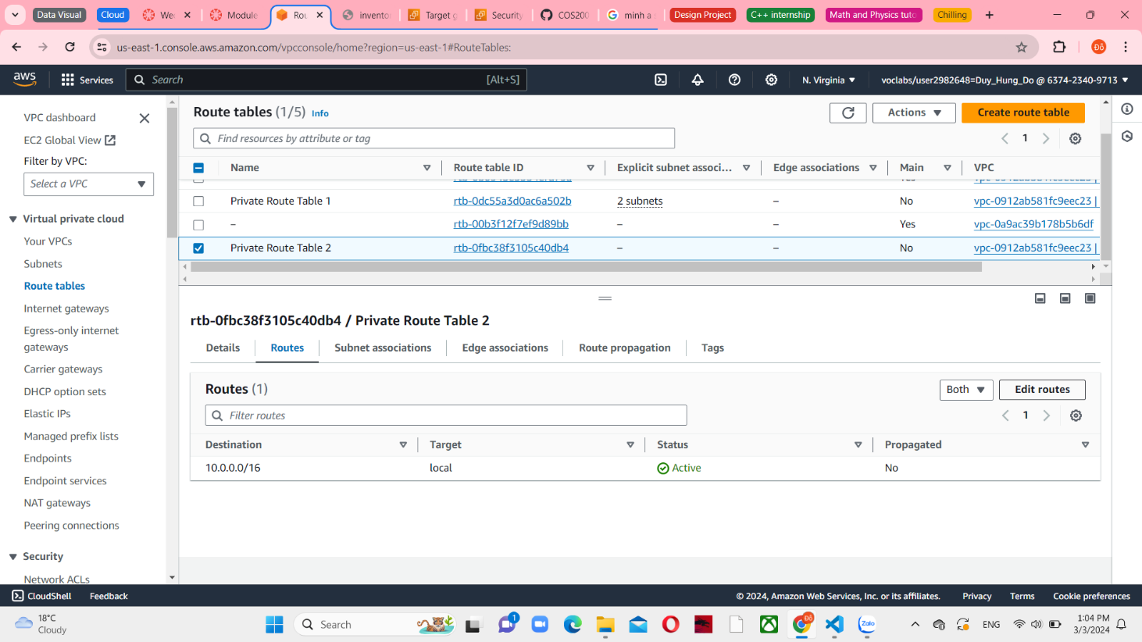

*Figure 69 Routes in Private Route Table 2*

Choose Edit routes and add the destination 0.0.0.0/0 as the default. And the target set the nat entry is the Public Subnet 2.

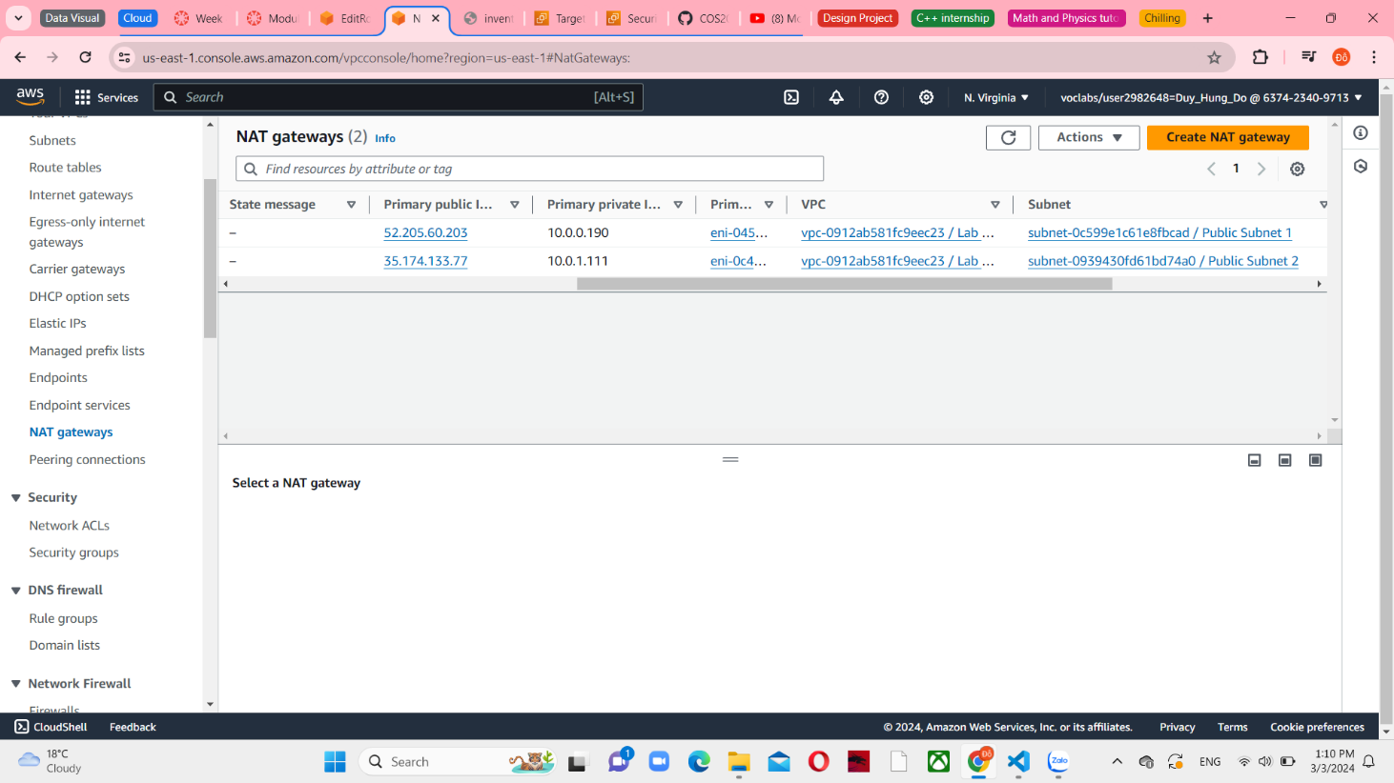

*Figure 70 The difference between NATGateway1 and other*

And then, choose Save changes and you will see a successful message. Continue with Subnet associations tab and edit it

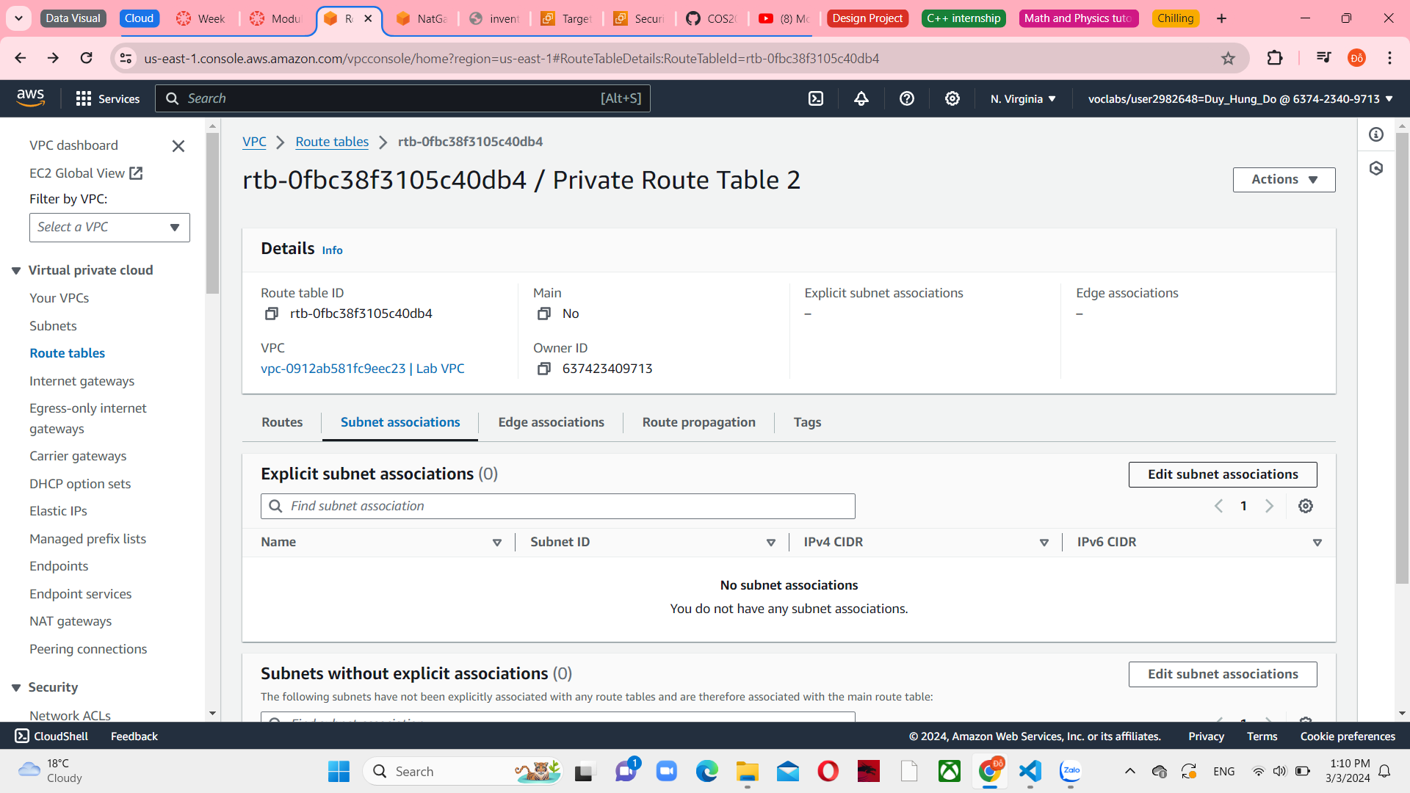

*Figure 71 Subnet associations in Private Route Table 2*

Select Private Subnet 2 and save associations. This step now routes internet-bound traffic from Private Subnet 2 to the NAT gateway located in the same Availability Zone.

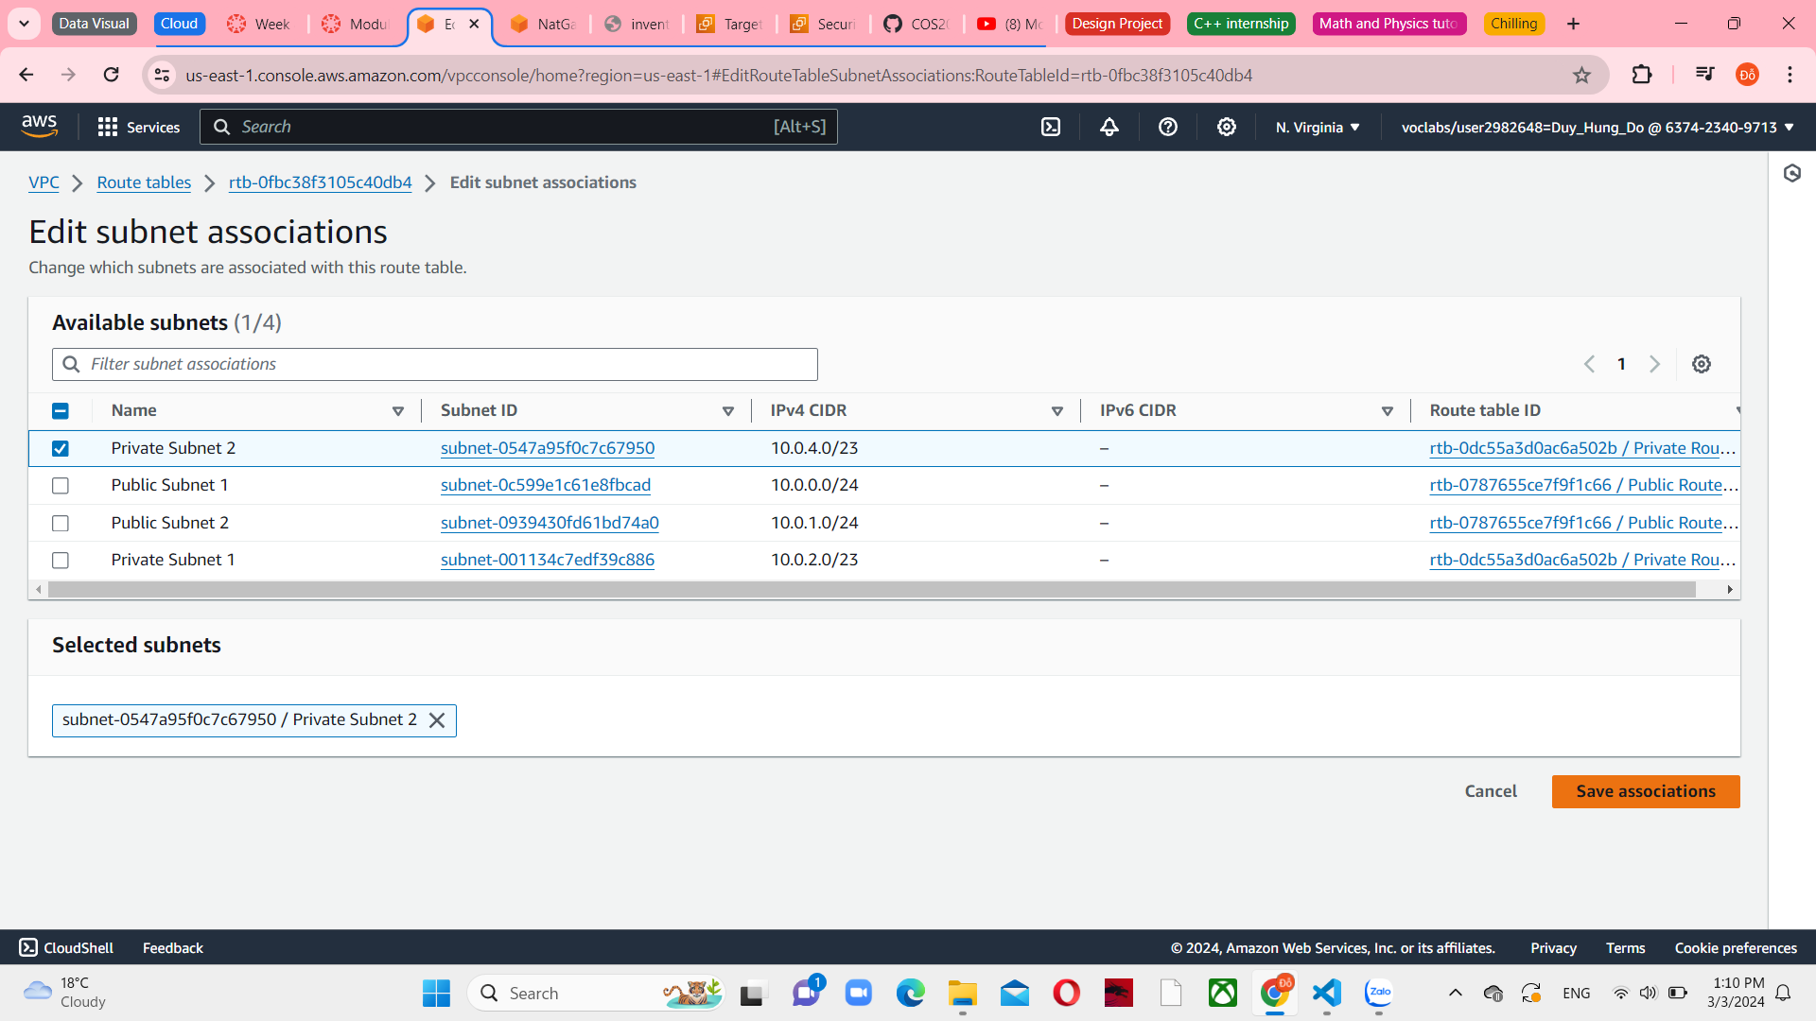

*Figure 72 Edit subnet associations*

Your NAT gateways are now readily available. If one Availability Zone fails, traffic in the other Availability Zone is unaffected.

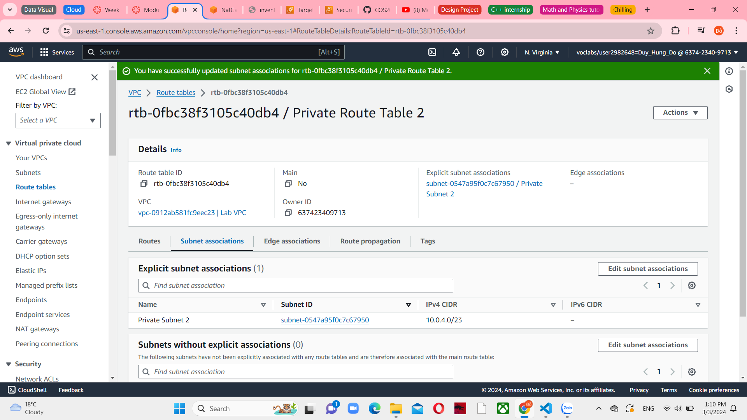

*Figure 73 Update subnet associations successfully*